Graduate School Guidelines for Submission of Thesis/Dissertation, etc., and Research Methodology

2025. 11. .



Table of Contents

Ⅰ. Guidelines for Submission of Master’s/Doctoral Degree Thesis/Dissertation, etc. 1
1. Master’s/Doctoral Degree Qualification Examination Schedule and Application Instructions 1
a. Foreign Language Examination 1
b. Comprehensive Major Examination 1
c. Examination Schedule 1
2. Submission Schedule and Instructions for Master’s/Doctoral Degree Thesis/Dissertation, etc. 2
a. Eligibility for Submission of Master’s/Doctoral Degree Thesis/Dissertation, etc. 2
b. Registration of Prospective Submitters of Thesis/Dissertation, etc. (Graduate Students) 2
c. Recommendation and Appointment of Thesis/Dissertation, etc. Examiners (Departments and Graduate School) 2
d. Submission of Thesis/Dissertation, etc. for Preliminary Review (Graduate Students) 2
e. Preliminary Review: Public Presentation (Graduate Students) 3
f. Final Review: Examination of Thesis/Dissertation, etc. and Oral Examination (Examiners) 3
g. Submission of Final Thesis/Dissertation, etc. (Graduate Students) 3
h. Deliberation on Conferral of Master’s/Doctoral Degrees (Graduate School Committee) 3
3. Writing Guidelines for Master’s/Doctoral Degree Thesis/Dissertation, etc. 3
a. Binding and Printing of Thesis/Dissertation, etc. 3
b. Thesis/Dissertation Writing Instructions 4
c. Format and Structure of the Thesis/Dissertation 7

Ⅱ. Research Methodology for Science and Engineering Master’s/Doctoral Theses/Dissertations, etc. 8
1. How to Write Science and Engineering Theses/Dissertations, etc. 8
a. Required Elements of a Thesis/Dissertation 8
b. Structure and General Guidelines 9
c. Detailed Requirements and Writing Guidelines for Each Section 10
2. Research Process for Preparing a Thesis/Dissertation 22
a. Thesis/Dissertation and Research 22
b. Research Methods and Procedures 23
c. How to Prepare a Thesis/Dissertation (Research) Proposal 29
d. References 32
Ⅲ. Research Methodology for Humanities Master’s/Doctoral Theses/Dissertations, etc. 33
1. How to Write a Thesis/Dissertation 33
a. Concept of a Thesis/Dissertation 33
b. Composition and Framework of a Thesis/Dissertation 34
c. Sentences and Writing Style 37
e. Citations and Notes 41
f. References 45
2. Fundamentals of Research Methodology 49
a. Concept of Research 49
b. Research Procedures 50
c. Research Topic 52
d. Literature Review 55
e. Types of Research 58
f. Data Collection 64
g. Data Analysis 70
h. References 72

Ⅰ. Submission Guidelines for Master’s/Doctoral Degree Thesis/Dissertation, etc.

1. Schedule and Application Instructions for Master’s/Doctoral Degree Qualification Examinations
a. Foreign Language Examination
1) Legal Basis: Articles 50 through 53 of the Korea National University of Transportation Graduate School Academic Affairs Regulations
2) Eligibility
a) Master’s Degree Program: A student who has completed at least one (1) semester of coursework and earned at least six (6) credits.
b) Doctoral Degree Program: A student who has completed at least two (2) semesters of coursework and earned at least nine (9) credits.
c) Scoring and Passing Criteria: The examination shall be scored out of 100 points, and a score of 60 points or higher shall constitute a pass. An applicant who fails may re-take the examination at the next scheduled sitting.
d) Preparation of Examination Questions and Standards
(1) Examiners: Examiners shall be appointed by the Dean of the Graduate School each semester.
(2) Standards: The foreign language examination shall be administered in English and shall consist of twenty-five (25) multiple-choice questions (four (4) options). It shall assess whether the examinee can read and understand English-language original texts in the major field.
b. Comprehensive Major Examination
1) Legal Basis: Articles 50 through 53 of the Korea National University of Transportation Graduate School Academic Affairs Regulations
2) Eligibility
a) Master’s Degree Program: A student who has completed at least two (2) semester of coursework and earned at least six (18) credits.
b) Doctoral Degree Program: A student who has completed at least two (3) semesters of coursework and earned at least nine (27) credits.
3) Scoring and Passing Criteria: To pass, an examinee must achieve (i) at least forty (40) points in each subject and (ii) an average score of at least seventy (70) points across all subjects. If the average score is below seventy (70) points, the examinee must re-take all subjects at the next examination. However, where the examinee has one or more failed subjects but has an average score of seventy (70) points or higher, the examinee may re-take only the failed subject(s) at the next examination.
4) Preparation of Examination Questions and Standards
a) Examiners: The question setter(s) for each subject shall be appointed each semester by the Program Chair.
b) Standards: The master’s program shall be examined in three (3) subjects, and the doctoral program shall be examined in at least four (4) subjects. Two (2) questions shall be set per subject. By assessing the level of competence in the primary major subjects and related secondary fields, the examination shall determine eligibility for the conferral of a master’s or doctoral degree.

c. Examination Schedule
1) Distribution and Receipt of Applications: Graduate School
a) Application Period: In accordance with the Graduate School academic calendar for the relevant year.
b) Required document: One (1) copy of the application form.
c) Application Form: Regulations [Appendix Form No. 3] and [Appendix Form No. 4].
2) Date/Time and Venue
a) Date/Time: Administered twice (2) per year, in April and October.
b) Venue: To be announced on the Graduate School website one (1) week prior to the examination date.
3) Announcement of Results: To be posted on the website on the designated date.
2. Schedule and Instructions for Submission of Master’s/Doctoral Degree Thesis/Dissertation, etc.
a. Eligibility to Submit a Master’s/Doctoral Degree Thesis/Dissertation, etc.
1) Legal Basis: Article 54 of the Korea National University of Transportation Graduate School Academic Affairs Regulations
a) A student who has passed the degree qualification examinations.
b) For the master’s degree program: A student who has completed the program requirements or who is expected to complete them by the end of the relevant semester.
c) For the doctoral degree program (including the integrated master’s–doctoral program): A student who has registered for at least two (2) semesters after completion of coursework.
d) For the doctoral degree program: A student who has fulfilled any additional mandatory requirements (e.g., journal publication) as separately prescribed by the department (major).
e) For international students: A student who meets the standards separately prescribed in the admissions process.
f) For an alternative thesis/dissertation track: A student who meets the requirements demanded by government human resources development projects.
b. Registration of Prospective Thesis/Dissertation, etc. Submitters (Graduate Students)
1) Registration Period: Spring cycle—late October; Fall cycle—late April.
2) Required documents
a) Application for Examination of Master’s/Doctoral Degree Thesis/Dissertation, etc.: Regulations [Appendix Form No. 6].
b) Examination Fee: To be determined separately.
3) Registration Office: Graduate School.
c. Recommendation and Appointment of Examiners (Departments and Graduate School)
1) Recommendation of Examiners: Department Chair (Spring cycle: October; Fall cycle: April).
2) Appointment of Examiners: Dean of the Graduate School (Spring cycle: October; Fall cycle: April).
3) Required document: Recommendation Form for Examiners for Master’s/Doctoral Degree Thesis/Dissertation, etc. (Regulations [Appendix Form No. 7]).
d. Submission of Thesis/Dissertation, etc. for Preliminary Examination (Graduate Students)
Thesis/Dissertation, etc. manuscripts for examination shall be prepared and submitted in accordance with the Graduate School’s Guidelines for Preparing Master’s/Doctoral Theses/Dissertations.
1) Submission Period: Spring cycle—early November; Fall cycle—early May.
2) Required documents
a) Examination Copies: Master’s—four (4) copies; Doctoral—six (6) copies (*perfect bound).
b) Summary of Master’s/Doctoral Degree Thesis/Dissertation, etc.: One (1) copy.
3) Submission Office: Department examiners
e. Preliminary Examination: Public Presentation (Graduate Students)
Pursuant to Article 62 of the Korea National University of Transportation Graduate School Academic Affairs Regulations, a submitter of a thesis/dissertation, etc. shall conduct a public presentation by major in the presence of the examiners.
1) Presentation Period: Spring cycle—mid-November; Fall cycle—mid-May.
2) Method: To be conducted internally by each department within the designated period prior to the main examination.
3) Reporting of Results: The Chair of the Examination Committee shall submit a written report to the Dean of the Graduate School in the prescribed form.
4) Required document: Preliminary Examination Result Report for Master’s/Doctoral Degree Thesis/Dissertation, etc. (Regulations [Appendix Form No. 8]).
f. Main Examination: Examination of Thesis/Dissertation, etc. and Oral Examination (Examiners)
Pursuant to Article 62 of the Korea National University of Transportation Graduate School Academic Affairs Regulations, the examiners shall verify and review whether the matters identified in the preliminary examination have been revised and supplemented, and shall determine whether the thesis/dissertation, etc. is free from defects as a degree thesis/dissertation in terms of content and structure.
1) Examination Period: Spring cycle—late November to mid-December; Fall cycle—late May to mid-June.
2) Method: The examiners of each department shall establish examination criteria and conduct the examination.
(Master’s: at least one (1) session; Doctoral: at least two (2) sessions.)
3) Examination Results: The Chair of the Examination Committee shall submit a written report to the Dean of the Graduate School in the prescribed form.
4) Required document: Main Examination Result Report for Master’s/Doctoral Degree Thesis/Dissertation, etc. (Regulations [Appendix Form No. 9]).
g. Submission of Final Thesis/Dissertation, etc. (Graduate Students)
The final thesis/dissertation, etc. shall be prepared and submitted in accordance with the Graduate School’s Guidelines for Preparing Master’s/Doctoral Theses/Dissertations.
1) Submission Period: Spring cycle—late December; Fall cycle—late June.
2) Required documents: Four (4) hardbound copies (master’s and doctoral) bearing the examiners’ signatures or seals on the Approval Page.
h. Deliberation on Conferral of Master’s/Doctoral Degrees (Graduate School Committee)
1) Deliberation Period: Spring cycle—mid-January; Fall cycle—mid-July.
2) Method: The Graduate School Committee shall deliberate based on the examination result reports for the Master’s/Doctoral Degree Thesis/Dissertation, etc.

3. Guidelines for Preparing Master’s/Doctoral Degree Thesis/Dissertation, etc.
a. Binding and Printing of the Thesis/Dissertation, etc.

Category | Specifications and Materials |  | Preparation Method
Category | Examination Thesis/Dissertation | Final Thesis/Dissertation | Method and Format | Remarks
Cover | A4  Perfect binding  Black-and-white | 4×6 format (188mm × 257mm)  Hard cover—gold-foil stamping on a black background | Single-sided or double-sided printing  (see sample) | Refer to the “Method for Preparing Theses/Dissertations”
Text (Inner pages) | A4  White or off-white woodfree paper of 80 lb or higher 4×6 format (188mm × 257mm) | White or off-white woodfree paper of 80 lb or higher | Single-sided or double-sided printing  (see sample) | Refer to the “Method for Preparing Theses/Dissertations”

1) When preparing the printed thesis/dissertation, the date shall be indicated as follows.
a) Cover and Inner Cover: Enter the month of actual graduation (the cover and inner cover shall match).
February 2025 (for English-language theses/dissertations)
b) Submission Section: Enter the month in which the degree thesis/dissertation is submitted.
December 2025 (for English-language theses/dissertations)
c) Approval Section: Enter the month in which the degree thesis/dissertation is approved by the examiners.
December 2025 (for English-language theses/dissertations)
b. Instructions for Writing the Thesis/Dissertation
1) Characteristics of a Thesis/Dissertation
a) A thesis/dissertation is a systematic piece of writing in which the author presents academic research results, opinions, and arguments on a given topic in a logical and properly structured manner.
b) To write a strong thesis/dissertation, the author should select a creative topic, conduct research by following appropriate methodologies, formats, and procedures, and present the content clearly and objectively.
2) Title
a) The title shall be stated concisely and clearly.
b) The title shall most succinctly reflect the content while clearly indicating what the thesis/dissertation addresses.
c) The title may reflect key characteristics of the thesis/dissertation, such as its method and subject (object of study).
3) Summary (Korean-Language Summary)
a) The Korean-language summary shall be concise and clear, and shall accurately present the purpose and overall content of the thesis/dissertation.
b) It shall include key word(s).
4) Numbering System
a) The numbering system for chapters, sections, subsections, and items shall be: Ⅰ, 1, 1), (1), ①.
b) Titles for chapters, sections, subsections, and items shall reflect a hierarchical structure and be sufficiently specific to allow the reader to broadly anticipate the overall content.
5) Language and Sentences
a) The thesis/dissertation shall, in principle, be written in Korean, Hanja (Chinese characters), and/or English.
b) Sentences shall be written in accordance with the prescribed format, taking into account sentence length, grammatical appropriateness, and logical coherence.
c) Tense: Present and past tense shall be used primarily. The present tense is used when citing theories, defining concepts and terms, and stating the researcher’s opinions. The past tense is used when citing findings of prior studies and when describing methods, results, and summaries.
d) Person: Use third-person references such as “the author” and “the researcher.”
e) Loanwords should, where possible, be translated into Korean. Where the translated term is unfamiliar or highly specialized, the original-language term shall be provided in parentheses.
6) Abbreviations, Symbols, and Numbers
a) Abbreviations and Symbols
Generally known loanwords may be abbreviated. Where the meaning may not be clearly conveyed, the original-language term shall be provided in parentheses.
b) Numbers
In principle, Arabic numerals shall be used. Numbers below 10 may be expressed as cardinal numbers, and ordinal numbers may be used to indicate ranking. Units of quantity should, where possible, use SI units.

<Table 1> SI Base Units
Quantity | Unit name | Symbol
Length  Mass  Time  Electric current  Temperature  Amount of substance  Luminous intensity | meter  kilogram  second  ampere  kelvin  mole  candela | m  kg  S  A  K  mol  cd

7) Tables and Figures
a) Tables
Tables shall be assigned consecutive table numbers, and the table number and title shall be placed at the top. Units (e.g., %, KRW) shall be indicated at the upper-right of the table. Where a table has a source, the source shall be provided at the bottom of the table.
b) Figures
Figures shall be assigned consecutive figure numbers, and the figure number and title shall be placed at the bottom center of the figure.
8) Citations and Notes
a) Direct Quotations
Direct quotations reproduce another author’s text verbatim. Short quotations shall be enclosed in quotation marks (“ ”) or 『 』. Long quotations shall be presented as a separate paragraph. At the end of the quotation, the author name, year of publication, and quotation range (page number(s)) shall be provided in parentheses, or a note (註) shall be inserted.
b) Indirect Quotations (Paraphrase/Summary):
Indirect quotation summarizes or rephrases another author’s research or literature in the researcher’s own words. Quotation marks shall not be used. The author name and publication year shall be provided, or the reference number shall be indicated in parentheses.
(c) Notes
Notes are used to indicate sources cited or consulted, or to provide supplementary explanations of the text. A small superscript number shall be placed at the upper-right of the end of the relevant sentence, and a line shall be drawn at the bottom of the page where the explanation shall be written in small type.
9) References
For science and engineering disciplines, references should be formatted using either the CS (Citation Science) style or the NY (Name–Year) style, and it is recommended that the citation and reference-writing methods used by the representative academic society of the relevant discipline be followed.
For humanities and social sciences, formats may vary by discipline; however, the APA (American Psychological Association) style commonly used in humanities and social sciences shall be followed.
a) Books
For Korean-language books, list in the following order: title, year, place, colon (:), publisher. For English-language books, capitalize only the first letter of the first word of the title and write the remaining words in lowercase; italicize the title.
b) Periodicals
For Korean-language periodicals, list in the following order: author name, year, title, journal name, volume (issue), page range. For English-language periodicals, capitalize only the first letter of the first word of the title and write the remaining words in lowercase; italicize the journal name and volume number
c) Magazines and Newspapers
For magazines, list: author name, (year and month), title, issue number, pages. For daily newspapers, list: author, (year, month, day), title, newspaper name, pages.
d) Translations:
For books translated into Korean, list: original author, year, translated title, original title (italicized for English), translator, place of publication, publisher, and provide the original publication year in parentheses.
e) Degree Thesis/Dissertation
For Korean degree theses/dissertations, list: author, year, title, degree-awarding institution, degree name.
10) Appendices
Appendices shall present materials not included in the research methods section or the main results (e.g., test instruments, questionnaires, interview questions), by assigning consecutive numbers.
11) Abstract (English-Language Summary)
The Abstract shall be written in English and, as with the Korean-language summary, shall focus on the research purpose, methods, and results. The English Abstract shall be within two (2) pages.
c. Structure of the Thesis/Dissertation
1) Outer Cover
2) Inner Cover
3) Approval Page
4) Acknowledgements - Optional, only where necessary
5) Table of Contents
6) Summary
7) List of Tables, Figures, and Photographs - Optional, only where necessary
8) Main Text
9) References
10) Appendices - Optional, only where necessary
11) Abstract

★ The thesis/dissertation shall be prepared strictly in accordance with the Graduate School’s prescribed thesis/dissertation preparation method and format.

Ⅱ. Research Methodology for Master’s/Doctoral Degree Theses/Dissertations in Science and Engineering
1. How to Prepare a Science and Engineering Degree Thesis/Dissertation, etc.
a. Requirements of a Degree Thesis/Dissertation
A thesis/dissertation is a tool for communicating research results, that is, knowledge discovered by the researcher, to others in the most objective manner possible. Research is a process of “observation” of a phenomenon, forming a “assumption/hypothesis,” and “proving” the hypothesis through logically sound and valid methods. Research results must be sufficiently “valuable” (in terms of level, creativity, contribution, and applicability), and must be presented in an objective and logical manner that is persuasive to any reader. In addition to the general characteristics of scholarly papers, a degree thesis/dissertation shall satisfy the following requirements:
1) Originality: Originality is a fundamental attribute for recognition of the value of research. Originality may be achieved through the following approaches:
- Using new materials or new data.
- Demonstrating differentiation from prior research methods.
- Providing a new interpretation of existing data.
- Approaching the issue from a new perspective.
2) Thoroughness: A degree thesis/dissertation shall be carried out under a detailed plan for literature review and/or experimentation, with care taken to avoid bias in data and omission of any part of the content.
3) Accuracy: When preparing a degree thesis/dissertation, accurate bibliographic information for cited sources shall be provided, and verified statistical data shall be used together with accurate recording of the cited materials.
4) Objectivity: The thesis/dissertation shall present clear facts or evidence supporting the researcher’s assertions, and the researcher’s emotions, biases, and preconceptions shall be strictly excluded.
5) Verifiability and Reproducibility: Research results shall be objectively verifiable by third parties. To this end, the source of data, research methods, and approaches used for problem-solving shall be presented accurately.
6) Ethics: The use of falsified data, the use of another person’s research without citation, or presenting an indirect quotation as a direct quotation is not permitted. Plagiarism and ghostwriting shall also be strictly excluded.
7) Structure/Format: The format of the submitted thesis/dissertation is an important requirement along with its content. The researcher’s ideas, research methods, experimental methods, and analysis of results shall be organized logically, and the prescribed thesis/dissertation preparation method shall be complied with.
b. Structure of a Thesis/Dissertation and General Guidelines
1) Structure: A science and engineering degree thesis/dissertation generally includes the following elements in order:
- Korean Abstract
- Table of Contents
- Introduction
- Methods
- Results
- Discussion
- Conclusion
- References
- English Abstract
- Appendix (as necessary)
2) General Guidelines: General guidelines to be followed when preparing a degree thesis/dissertation are as follows:
① Printing Format
- Use 4×6 format paper and write horizontally, ensuring that no page contains more than 33 lines.
- The item numbering system shall be used consistently throughout the thesis/dissertation in the following order: Ⅰ, 1, (1), 1).
- Page numbers shall be included.
- Other printing formats (e.g., outer cover, approval page) shall follow the separate forms provided in the Graduate School handbook.
② Abbreviations and Symbols
- Abbreviations and symbols shall be used only where they can be readily understood and are deemed helpful for reading the thesis/dissertation. Where an abbreviation is used for the first time, its meaning shall be defined in parentheses. A list may be provided before the main text to facilitate reference.
- Where an abbreviation is extremely common, it may be used without explanation.
③ Units: Units of measurement shall be expressed using SI units. However, where a traditionally used unit is more commonly used than the SI unit, an exception may be made.
<Table 1> SI Base Units

Quantity | Unit name | Symbol | Quantity | Unit name | Symbol
Length  Mass  Time  Electric current | meter  kilogram  second  ampere | m  kg  s  A | Temperature  Amount of substance  Luminous intensity | Kelvin  mole  candela | K  mol  cd

④ Chemical and mathematical expressions: Chemical reaction equations, structural formulas, mathematical formulas, etc. shall be written on a separate line between the lines of the main text. The naming of chemical substances, enzymes, etc. shall follow the recommendations of the International Scientific Union.
⑤ Tables and figures
- Tables and figures shall each be numbered sequentially in Arabic numerals in the order they appear in the main text. A List of Tables and a List of Figures may be placed before the main text to facilitate reference.
- For tables, write the title at the top and assign a column heading for each column indicating the content of that column. Legends and footnotes may be used so that the table content can be understood without referring to the main text.
- For figures, write the title and provide explanatory text centered beneath the figure. As figures are intended to show an overall form or a pattern of change, they shall be simple and concise, and the overall outline shall be readily visible at a glance. Select an appropriate figure type that matches the nature of the data, and use universal symbols where possible. Where graphs are included, clearly specify the units and content of both the x-axis and y-axis.
⑥ Notes: When citing references in the main text, in-text citations shall be used. Where supplementary explanation is required in the main text or in tables, footnote marks may be used and annotations may be provided at the bottom of the relevant page.
⑦ References: The department shall select, from among methods commonly used in relevant fields, the rules for preparing the references list and the method of citation; however, a single method shall be applied consistently throughout the entire thesis/dissertation.
c. Detailed Requirements and Writing Guidance for Each Section
1) Title
Separating the “topic” from the “title” may enhance understanding of the title. A research topic refers to the question to be answered by selecting a research subject and analyzing it, whereas the thesis/dissertation title includes the answer to the question—i.e., new findings or claims that represent the results of the analysis. Accordingly, while the topic generally becomes clear at the research proposal stage, the title is commonly finalized after research results have been obtained.
If the research results require an explanation too long to be summarized in a few words, a title that indicates only the research subject may also be useful. However, a title that does not indicate the research subject, or is not sufficiently specific, is not appropriate. <Table 2> presents examples of thesis/dissertation titles by contrasting titles that do not indicate a specific subject with titles that do indicate a specific subject. <Table 3> presents examples of thesis/dissertation titles by contrasting titles that do not indicate a specific subject with titles that do indicate a specific subject. In each table, the examples in the right-hand column may be regarded as more desirable thesis/dissertation titles than those in the left-hand column.

<Table 2> Comparison of Thesis/Dissertation Titles 1

Title not indicating a specific subject | Title indicating a specific subject
Title indicating a specific subject | Kansei-engineering-based quantification of the gripping feel, operational feel, and response sound of manual control components
Application of GT in warship design and production | Platform family configuration using GT in warship design and production

<Table 3> Comparison of Thesis/Dissertation Titles 2

Title indicating only the research subject | Title indicating the research subject plus the claim and results
A case study on the design of a decision support system for make-to-order manufacturers | Development of a decision support system for make-to-order manufacturers incorporating proactive management of potential loss factors
Introduction of the number portability system and network effects | Introduction of the number portability system: growth of the mobile telecommunications service market and enhancement of welfare
A study on network design development for news television | Formulating differentiation strategies for news television in the multi-channel era through network design development

In general, the following points should be observed when determining a degree thesis/dissertation title:
① Include descriptive and clear information that attracts attention.
② Ensure the title aligns with the research objectives.
③ Ensure the title accurately represents the content and is expressed specifically.
④ Avoid the use of abbreviations, slang, and product names.
⑤ Avoid using subtitles where possible.
⑥ Do not use expressions such as “A Study on …” or “A Review of …”.
⑦ Place important words first.
Example) Impact of (A) on (B) in (C)
(A) Species
(B) Independent variables
(C) Dependent variables
2) Abstract
An abstract is a structured summary designed so that a reader can accurately understand the core content of the degree thesis/dissertation without reading the full text. It shall concisely describe: ① the basic objectives and scope of the research, ② research materials and methods, ③ a summary of research results, and ④ conclusions. The length shall be 1–2 pages.
a) Korean Summary
① Function: An overview of the thesis/dissertation—its content should be understandable even when read on its own.
② Content: All major areas of the thesis/dissertation shall be included.
- Why (question): purpose (Introduction)
- How (what was done): subjects and methods
- What (what was found): results
- So what (answer) / conclusion: discussion and conclusion
- Other (background, implications, speculation)
* In the abstract, do not cite references and do not use tables or figures; in most cases, it is written in approximately 200–250 words.
③ Notes: Write as concisely as possible. With busy readers in mind, avoid abstract expressions and clearly present key figures where considered important. When describing tense, express the question in the present tense and the methods and results in the past tense. Unless necessary, avoid using the present perfect or past perfect. Do not use abbreviations.
b) English Abstract
The English abstract shall be within 250 words and shall use a prescribed structured format divided into four parts: Background, Methods, Results, and Conclusion.
* Selection of key words: Select up to six (6) key words that represent the core of the thesis/dissertation and present them at the end of the abstract (in Korean for the Korean abstract and in English for the English abstract).
* In an era where computer-based literature searches are common, careful selection of key words is necessary so that one’s research paper can be more easily discovered and therefore cited more frequently.
3) Introduction
The introduction is the opening section of the degree thesis/dissertation. It shall present the purpose of the research in a reasonable and persuasive manner, so as to draw the reader’s interest in the research topic. It is important to clearly state the research objectives—i.e., what problems this research seeks to present and solve. The literature review should be conducted in that context to be effective. Specifically, after explaining the results of prior studies as the background leading to the problem addressed in this research, present the purpose and necessity of this research. This section aims to stimulate the reader’s interest and provide preliminary information to help readers begin reading the thesis/dissertation. Where possible, it should be written concisely and clearly, using specific approaches rather than broad ones, describing how the researcher moved from what is known to what is unknown, and what experimental efforts were made to clarify the research questions. In general, the introduction should include:
- Explanation of the research topic addressed in the thesis/dissertation, including its significance and importance.
- Statements of known facts or debated issues that are directly relevant to the thesis/dissertation, based on review and analysis of references.
- Description of the objectives and necessity of the research and its novelty, based on the above.
- A brief description of the specific scope and methods of the research.
To present such content, it is not advisable to provide textbook-style explanations or lengthy historical background covering too many papers. Choose cited papers carefully and write concisely, clearly, and logically so that readers can begin reading without difficulty. More specifically, the following should be mentioned and explained objectively and logically in the introduction:
- Through analysis of already known facts or currently raised issues related to the research task, logically derive the elements, items, or relationships that should be pursued. In other words, through a literature review of knowledge related to what is known or believed about the research task, derive unknown facts or issues where problems are being raised.
- Based on this process, concretely state the research objectives—i.e., what problems this research seeks to present and solve.
- Confirm that the research methods to be used are clear. Specify the experimental subjects, experimental environment, materials, etc. to be studied in detail.
- Finally, present the significance and importance of the research task.
4) Methods
All research may yield different conclusions depending on the research methods used. Accordingly, an appropriate research method should be selected for the problem posed, and conclusions should be derived using a more appropriate method that differs from prior research or corrects errors in prior research. The Methods section shall describe the research process in detail and explain how the method selected by the researcher differs from existing methods and why such a method was adopted. In general, the Methods section should include:
- A detailed description of research materials, equipment, and methods, together with the reasons for selecting them.
- A detailed description of the experimental process. A specific description of experimental instruments and materials, treatment methods, measurement methods, number of experimental repetitions, etc., so as to eliminate potential grounds for future dispute. Sufficient detail so that other researchers can perform the same experiment by following the described experimental procedures. In addition, it should be possible to obtain the same results as those in the thesis/dissertation regardless of who conducts the experiment, when, or where.
- Where the description of the experimental process becomes overly long or complex, divide it into experimental materials, experimental methods, experimental conditions, etc.
5) Results
The Results section describes the outcomes obtained through the research process. When presenting results obtained through experiments or observation, it is more effective to use visual materials than to rely on text alone. Use tables, bar graphs, line graphs, pie charts, etc., selecting the most effective format for presenting the results. In general, the Results section should include:
- Present results in a logical order consistent with the research objectives or hypotheses, i.e., from indirect to direct content, and from general to specific content.
- State the key result the researcher intends to present in a simple sentence at the beginning of each paragraph or as a subheading, and then present the related data. Depending on the specificity of the research, results may be divided into several independent sections for presentation and explanation.
- Re-mention, in the first sentence of the Results section, the experimental materials or equipment used, and verify the linkage that the experimental methods used to obtain the results are reflected in the Methods section.
- Describe experimental results in the past tense (especially in English).
- Minimize listing data in the body text; present most data, especially important data, in tables, graphs, or figures. Place tables and figures as close as possible to the relevant text in the Results section.
In particular, note the following when describing results:
- Describe results objectively and avoid distorted presentation.
- Because tables and graphs serve to support clearer understanding, explain their content in the text in sufficient detail. Do not present tables or graphs without adequate explanation and leave readers to analyze them on their own.
- Do not include results that are irrelevant (or have become irrelevant) to the process of reaching conclusions. Even if the researcher invested substantial effort in such parts, they should be omitted decisively.
6) Discussion
Discussion of the results is the core of the thesis/dissertation. The Discussion section is the stage of interpreting or inferring what is needed to derive conclusions in connection with the research objectives presented in the Introduction. Therefore, it shall explain how the results support the conclusions and how those conclusions align with existing facts. Because this section must argue the significance and importance of the research results logically and objectively through a valid reasoning process, it should not be confused with a simple repetition of the Results section. Describe the meaning of the experimental results and what can be learned from them. Also describe the limitations of the experiment and cite papers with opposing results. The content to be addressed and the recommended structure in the Discussion section are as follows:
a) Content of the Discussion
① Present answers or new facts regarding various questions under the research objectives.
② Support the research conclusions by using the researcher’s results (citing figures and tables as necessary) together with other researchers’ results that are relevant.
③ Explain why the conclusions are valid and how they align with previously published facts. Cite only literature essential to interpreting one’s experimental results, and avoid excessive listing of other researchers’ results.
④ Present and explain, in an organized and logical manner, any methodological limitations and the validity of assumptions underlying the method.
⑤ If there are unexpected findings, or findings that contradict previously published facts such that interpretation or inference cannot be made based solely on known concepts, state them clearly and present opinions on new directions that may be inferred and on tasks that require continued research to clarify such issues.
b) Structure of the Discussion
① Begin by presenting specific answers obtained through the experimental results of this research to the questions initially raised in relation to the research objectives. Restating the initial questions and briefly showing the context in which they were addressed may aid understanding.
② Then, use the experimental results obtained through this research to find answers to the initial questions. In this process, sufficiently review other researchers’ results and discuss them by comparing them with one’s own results. The reasoning process leading to conclusions should avoid logical leaps and be developed rationally to produce a persuasive thesis/dissertation.
③ Next, if there are experimental results that do not support the conclusions, results that do not align with other researchers’ results, or unexpected findings, include explanations for them. It is also advisable to explain methodological limitations or weaknesses.
④ Finally, describe the importance of the research results. Because this section addresses multiple matters, it is advisable to group related topics step-by-step in each paragraph; however, it is important to develop an overarching argument throughout the Discussion section as a whole.
7) Conclusion
The Conclusion section summarizes research results and presents the final assertions. Summarize the discussed content and present the final conclusions faithfully and clearly, preferably within a length not exceeding 10% of the thesis/dissertation. In general, the Conclusion should include:
- A summary of facts identified through the research
- Answers to the questions raised in the Introduction
- The significance of the research
- Limitations of the research
- Suggestions for follow-up research
8) Source Citation and Preparation of References
a) Methods of Source Citation and Preparation of References
“Source citation” refers to the act of disclosing the original source while using another person’s writing or ideas as-is or in an adapted form as needed. Typically, source citation is performed through notes or annotations. Using another person’s writing or ideas without source citation constitutes “plagiarism,” and therefore careful attention must always be paid to source citation. Notes may be classified, by form, into in-text citations (where the source is indicated in parentheses within the text) and external notes (where the source is indicated outside the main text), which are further divided into footnotes and endnotes. In science and engineering papers, in-text citations are used as the principle. To use in-text citations, a references list must be prepared using a consistent method.
There is no single standardized method for source citation. Practices vary by journal and discipline, so the best approach is to confirm the citation style required by the journal to which one intends to submit and follow that style. For degree theses/dissertations as well, the citation and references style of the representative academic society for the relevant field, as determined by each department, should be followed.
One of the most standard citation methods used in the sciences is the manual edited by the Council of Science Editors (CSE). CSE first published its manual for publication in 1960, and the 7th edition was published in 2006. Because many journals and publications across scientific fields generally establish publication rules based on this manual, the following outlines source citation and references preparation methods under it.
① CS (Citation–Sequence) Style
- Source citation: In the CS style, the reference number in the references list is indicated in sequence, either as a superscript or inside square brackets or parentheses; this is the most widely used method. Because citations in the text are handled only by inserting Arabic numerals in brackets ([ ] or ( )) or as superscript numerals, it is not necessary to write the author’s name in the text; full information about the author, paper, publisher, etc. is presented in the references list.
(Example) In a related study[1], …
- Preparation of references: Assign a unique sequential number to each reference at the beginning of the entry. The number may be followed by a period (e.g., 1.), or placed within square brackets or parentheses. Then, for journal articles, include the author, article title, journal title, volume, issue, page range, and year; for books, include the author, book title, publisher, publisher location, page range, and year.
(Examples)
[1] Yao Wang, and Qin-fan Zhu, "Error control and concealment for video communication: A Review," Proceedings of the IEEE, 86(5), pp.974-997, 1998
[2] Huifang Sun, Xuemin Chen, Tihao Chiang, Digital Video Transcoding for Transmission and Storage, CRC Press, 2005

- Fields of use: The CS style is mainly used in chemistry, computer science, mathematics, physics, medicine, pharmacy, nursing, public health, and related fields.
② NY (Name–Year) Style
- Source citation: In the NY style, the references list is arranged in Korean alphabetical order or English alphabetical order, and citations use the author name and publication year. In the main text, the cited source is inserted in parentheses with the author name and year. Where the author’s name is mentioned directly in the text, only the publication year is provided in parentheses.
(Examples) A recent report (Jang, Yeong-sil, 1980) … According to the research findings of Jang Young-sil (1980) …
- Preparation of references: Arrange the references list in Korean alphabetical order or English alphabetical order; where there are multiple works by the same author, arrange them in chronological order. For journal articles, list author, year, title, journal title, volume, issue, and pages. For books, list author, year, book title, publisher name, publisher location, and pages.
(Examples)
Park, Seong-min. 2000. A study on effective adaptation measures for exotic arboretums in Jirisan, Korea. Korean Society of Forest Science, 55, pp. 21–53.
Park, Seong-min; Seo, Myeong-su; Lee, U-taek. 1999. Status and improvement measures for the protection and management of old tree resources in Korea. Title. Journal of Korean Society of Forest Science, 49, pp. 340–351.
- Fields of use: The NY style is mainly used in agriculture, astronomy, biology, geology, archaeology, and related fields.
b) Recommended Reference Models
As noted above, it is recommended that degree theses/dissertations follow the source citation and references preparation method of the representative academic society for the relevant field, as determined by each department. Accordingly, by reviewing model formats for source citations and reference lists used by major societies in science and engineering fields, students may gain a more concrete understanding of proper citation and reference-writing methods.
- Institute of Korean Electrical and Electronics Engineers: http://www.ikeee.or.kr/5s-02.html
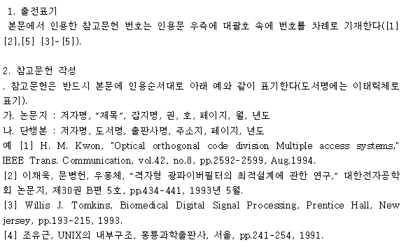

- Korean Society of Mechanical Engineers: http://www.ksme.or.kr/onpcs/contor/99.asp
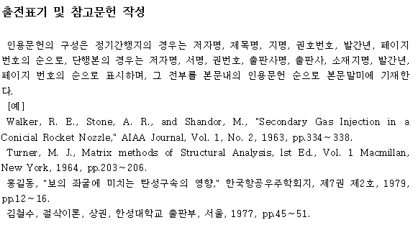

- Materials Research Society of Korea: http://www.mrs-k.or.kr/sub5/sub5_4.php

- Korean Chemical Society: http://newjournal.kcsnet.or.kr
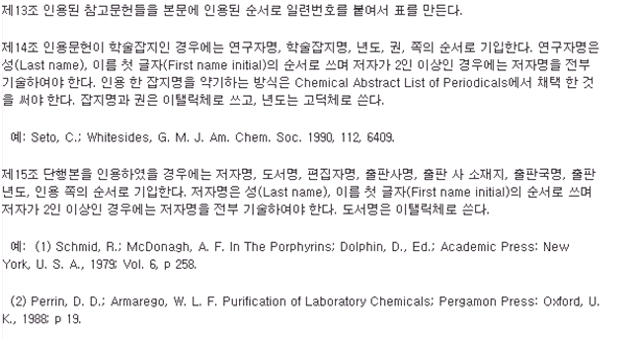

- Korean Society for Microbiology and Biotechnology: http://www.kormb.or.kr
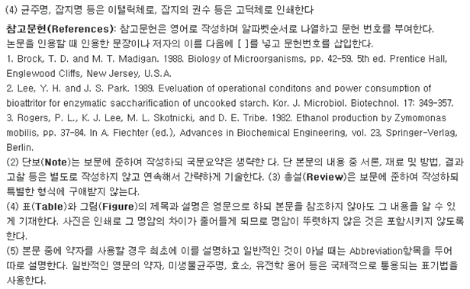

- Architectural Institute of Korea: http://www.aik.or.kr/

5. Method of Notes (Footnotes)
5.1 General Rules for Notes
(1) In principle, all notes shall be provided as footnotes.
(2) Where a note is required, a sequential note number in parentheses shall be placed at the upper right of the last character of the relevant portion, and the corresponding note number and explanation shall be provided at the bottom of the page.
Example) ……the earliest use of the tower crane21) ……
5.2 Notes for Cited References
(1) Where a quotation appears in the text, it shall be indicated with quotation marks (“ ”) and the source shall be identified; the citation shall be provided as a footnote in the same manner as general notes.
Example) “A house is a machine for living in”15) ……
(2) In footnotes, citations of references shall, as a standard, be indicated in the following items and order:
① Where the source is a monograph (book):
Author name, book title, edition, publisher, place of publication, cited page(s), year of publication
Example) Lee Mong-ryong, Architectural Planning Theory, 3rd ed., Cheongunsa, Seoul, p.54, 1993.
Example) Lynch, Kevin & Hack, Gary, Site Planning, 3rd ed,. MIT Press, Cambridge, p.132, 1994
② Where the source is a periodical (journal):
Author name, article title, periodical title, volume, issue, cited page(s), year of publication
Example) Lee Do-ryeong, “On Measures to Prevent Cracking of Concrete,” Journal of the Architectural Institute of Korea, Vol. 12, No. 14, pp. 145–150, 1993.
Example) Mylrea, T.D., “Bond and Anchorage,” Journal ACI, Vol. 59, No. 7, pp. 71–75, 1988.
③ Where the source is a series/collection (edited volume, compilation):
Author name, article title (editor name, book title, edition, volume), cited page(s), publisher, year of publication
Example) Hong Gil-dong, “Construction of Lightweight Concrete” (Kim Saeng-nyeon, ed., Concrete Construction Handbook, 2nd ed., Vol. 2), Geonseolsa, Busan, p.552, 1988.

6. Method of Listing References
References shall be listed collectively at the end of the main text, and the items and order of entries shall follow 5.2(2).

9) Appendices
Appendices are records supplementary to the main text of the thesis and shall include the following materials, which are not necessarily essential to the main text:
- Materials that are too detailed or voluminous to be included in the main text
- Supplementary tables, figures, statutory provisions, data, computer programming materials, survey forms, questionnaires, maps, and other materials related to the content of the main text
- Copies of materials that are difficult for the general reader to obtain
- Other supplementary materials of lesser importance

2. Research Process for Preparing a Degree Thesis
a. Degree Thesis and Research
1) What Is Research?
The English term most commonly used to refer to research is “research,” and related terms include “investigation,” “study,” and “survey.” Strictly speaking, “research” refers to rigorous, careful, and critical inquiry, while “survey” refers to an investigation conducted to identify phenomena, trends, characteristics, causes, and related factors. Meanwhile, “investigation” refers to an activity that closely examines facts or phenomena—i.e., research that delves deeply into a narrower scope—whereas “study” refers to research in a relatively broad or vague sense, and often denotes the act and result of learning rather than research itself. In general, research refers to an activity that, based on a systematic plan, collects data and analyzes and interprets it in order to find reliable solutions. When research disregards systematic and scientific procedures and thereby loses its scientific rigor, its value is diminished. The value of research does not derive from whether the outcome is large or small; rather, it depends on how scientific and systematic the process is. The general characteristics of research are as follows:
- It must be related to problem-solving.
- It must predict phenomena and facts through the establishment of principles and theories.
- It must be grounded in empirical evidence.
- It must rely on accurate observation and description.
- It must be organized and systematic.
- It must be supported by specialized knowledge or experience.
- It must maintain objectivity and logical consistency.
- It must be problem-oriented.
- It must be continuous.
- The research results must not be distorted.
2) Research Procedure for a Degree Thesis
The general characteristics of research described above should, of course, be applied equally to research conducted for the purpose of preparing a Degree Thesis. With an awareness of what research should be, this section outlines specific procedures for preparing a Degree Thesis and introduces research process methods in accordance with those procedures. First, a general research procedure for science and engineering Degree Theses is as follows:
- Selection of a research topic
- Investigation/analysis of related research
- Establishment of research methods/techniques
- Experimentation and implementation
- Revision and supplementation
b. Research Process Methods and Procedures
1) Selecting a Research Topic
In many cases, the process of selecting a research topic for a Degree Thesis is carried out through consultation with the Academic Advisor, and it is common for the topic to be set within the scope of the research themes of the laboratory to which the graduate student belongs. Accordingly, a specific research topic is frequently assigned. Nevertheless, when selecting a research topic, it is desirable to satisfy the following criteria:
- Select a topic in which the researcher has genuine interest in the field.
- Select a topic for which experiments or investigations are feasible under the given circumstances.
- By attempting to answer the research question independently, confirm what you intend to discover and what you wish to state and argue.
In addition, even if part of a laboratory’s joint research theme is adopted as the Degree Thesis topic, whether it is oriented toward practical applications or toward theoretical and academic inquiry, it is an essential requirement to set the topic with a focus on originality.
2) Investigating and Analyzing Related Research
Once a research topic has been established, it is essentially equivalent to being given a problem that must be solved. Reviewing prior studies related to the problem is extremely important and must be conducted meticulously. The scope of prior research to be reviewed is determined by the nature of the problem to be solved. For example, suppose the topic is “A Study on Biological Hydrogen Energy Production Technologies,” and the problem to be solved is to demonstrate the superiority of biological production technologies by comparing and analyzing them against other production technologies that could compete with them. In that case, this study requires not only prior research at the theoretical and technical levels regarding biological hydrogen production technologies, but also data concerning economic competitiveness. If the study involves the use of microorganisms, research materials concerning the maturation, cultivation, and characteristics of the relevant microorganisms are also important. Furthermore, prior research on alternative production technologies, such as water electrolysis technologies, as well as corporate or research-institute analysis materials regarding economic competitiveness may also be necessary.
As such, when investigating prior research related to the topic, one comes to understand the core concepts and theories surrounding the problem to be solved. Through this process, the research topic becomes more refined; and as the topic is refined, the scope of related research that must be re-examined becomes clearer—forming a recurring cycle.
To investigate related research effectively, an information-search strategy is required. Many researchers devote substantial time, cost, and effort to obtaining necessary information, but their methods are often inefficient. To search for and utilize information effectively, it is necessary to determine when and what information should be used, and to establish detailed search strategies. In addition, when searching for information online, it is insufficient merely to know key terms or subject terms. One must decide what type of literature or information in which field is needed, and whether materials are required regardless of publication period or only the most recent materials. Finally, it is necessary to be familiar with at least the representative search sites in the relevant field. More specific methods for utilizing reference materials are as follows:
a) Literature
General literature includes introductory books, dictionaries, and classics that contain general and introductory content across science and technology. In contrast, academic monographs and scholarly journals contain the latest theories and information. If you wish to confirm broad background knowledge regarding a topic of interest and to understand the current level of development in the field, you should utilize introductory texts and dictionaries. However, if you wish to identify the level reached by the latest theories or technologies and to determine what research is currently underway, you should examine scholarly monographs and journal articles. Journal articles may be accessed by using university libraries or online services provided by institutions such as the National Research Foundation of Korea(www.nrf.re.krwww.nrf.re.kr) or the Research Information Sharing Service (RISS)(www.riss.krwww.riss.kr). In addition, the National Digital Library (www.dlibrary.go.krwww.dlibrary.go.kr) may be used to obtain a wide range of information. Moreover, various information may also be obtained through the online encyclopedia Wikipedia (www.wikipedia.org www.wikipedia.org).
b) Scholarly Journals and Periodicals
Scholarly journals and other periodicals contain articles that academically organize the latest theories and research outcomes. Therefore, in order to identify recent research trends and findings related to a research topic, it is essential to locate and review relevant scholarly journals. Although university libraries typically provide access to periodicals in each field, it is difficult for any single university to hold every publication. By using the Comprehensive List of Foreign Scholarly Journals published by the Industrial Technology Information Center, it is possible to identify more easily which institutions hold periodicals in a given field. In addition, Journal Citation Reports (JCR) regularly evaluates the citation impact of approximately 1,000 scientific journals that are widely used worldwide. By using JCR, one can confirm which periodicals are considered more authoritative.
c) Indexes and Abstracts
When searching domestic and international journal articles via the internet, a large number of papers related to one’s topic of interest will appear in the search results. It is typically impossible to read every document among hundreds, and sometimes more than 1,000, papers in order to determine which ones are truly relevant to one’s research topic. In such cases, the researcher should first determine whether a paper appears necessary based on its title, and, if it seems potentially relevant, further select the most appropriate papers by reviewing the index terms and the abstract. Because digital libraries provide general bibliographic information for all holdings, and because scholarly articles include abstracts, it is possible to judge whether an article is needed without reading the entire paper. Widely known resources for checking and utilizing indexes and abstracts include Applied Science and Technology (Wilson), Chemical Abstracts (ACS), Current Contents (ISI), Engineering Index (EI), and the Science Citation Index (SCI). In Korea, Korean Scientific Abstracts provided by the Industrial Technology Information Center (KINITI) is also available. It is published in book form and is held by many university libraries, making it convenient to use. It is also an effective method to use SCOPUS, the world’s largest citation and abstract database published by Elsevier.
d) Reports
Among reports, experimental reports, research reports, and review reports on technologies or theories can provide very important information for solving research problems. They are particularly useful when objective, verifiable evidence is required. NTIS, a collection of research reports compiled and published in the United States, may be obtained through the Industrial Technology Information Center. The Industrial Technology Information Center also provides various research reports collected domestically, and these resources may be utilized as well. In addition, research institutions such as the Korea Institute of Science and Technology Evaluation and Planning (ww.kistep.re.krwww.kistep.re.kr), and the National IT Industry Promotion Agency (www.nipa.kr(www.nipa.kr) can be used to obtain a wide range of national R&D project reports in the field of science and technology, which can be highly useful. These institutions may also provide reports online in digital document form; therefore, users can often access them conveniently by registering on the relevant websites.
(e) Patents
Patents constitute highly important information when one intends to commercialize research outcomes, either immediately or in the future. Conversely, when conducting research with commercialization in mind, patent information is essential and must be reviewed. This is because, if the same or a similar technology has already been registered as a patent, it may be unnecessary to conduct the research again, or the research topic should be set to focus on a more advanced technology building upon the existing patent. In Korea, patent information may be searched through the Ministry of Intellectual Property (www.kipo.go.kr).
3) Establishing Research Methods/Techniques
For the preparation of a science and engineering degree thesis, the research method is typically empirical rather than literature-based. Moreover, it must be empirical and, at the same time, scientific. Scientific research always derives theory from scientific facts verified through empirical evidence that we can observe. The resulting theory, in turn, predicts new scientific facts, and those predictions must be verifiable through empirical evidence. In other words, scientific knowledge must be repeatedly verifiable by other researchers as to whether it is true. In addition, scientific research methods must ensure reproducibility of research results, and it must also be possible to replicate the research procedures used to obtain those results. Therefore, in order for a researcher to claim that the results obtained through their research constitute scientific knowledge, the researcher must present, in concrete terms, the research procedures carried out to obtain the results, thereby demonstrating that the procedures are replicable. The more replicable the research procedures are, and the higher the reliability of the measurement instruments used for data collection, the higher the reproducibility of the research results becomes.
Although research methods for a degree thesis must be scientific, the establishment of specific research methods or techniques inevitably varies significantly by research field even within science and engineering. In general, except in cases where the research topic requires theoretical or mathematical proof, many science and engineering degree theses adopt empirical research methods that collect data through experiments and observations and analyze the results. For example, if the field is computer science, the researcher must determine which methods or techniques will be used to solve the task derived from the research topic established within computer science. If the problem to be solved is highly application-oriented, the researcher may implement it as a computer system and obtain the desired conclusion through experiments. If it is theoretical in nature, the desired outcome may be achieved through mathematical proof. In the process of implementation and experimentation, or mathematical proof, the most important point is that the process should be carried out in a way that can clearly demonstrate what improvements the researcher’s experimental and implementation results bring compared to existing research.
<Table 4> presents several representative examples of how to structure the Methods section, focusing on specific items that fall within the scope of the research method domain.
<Table 4> Examples of Methods Section Structure

Methods Section Structure Example 1 | Methods Section Structure Example 2 | Methods Section Structure Example 3 | Methods Section Structure Example 4
① Research Subjects  ② Measurement Instruments  ③ Experimental Methods and Procedures  ④ Research Period | ① Survey Population and Sampling Method  ② Measurement Method  ③ Analysis Method  ④ Research Period | ① Experimental Subjects and Sampling Method  ② Experimental Instruments  ③ Measured Variables  ④ Experimental Plan  ⑤ Analysis Method | ① Measurement Targets and Measurement Method  ② Sampling Method  ③ Measurement Instruments  ④ Analysis Procedures

4) Experiments and Implementation
Unlike the social sciences, where data are often collected through surveys and analyzed statistically, research methods in science and engineering are primarily grounded in repeating experiments under various experimental conditions within a controlled laboratory environment. Accordingly, collecting data through experiments and analyzing those data can be regarded as a representative research method for science and engineering degree theses. Because experimental results are accumulated over extended periods, ranging from several months to several years, it is also critically important to collect, organize, and manage all results without omission. To this end, preparing systematic laboratory reports is a fundamental requirement. An experimental report should describe not only the experimental outcomes but also the rationale for conducting the experiment, the methods and materials used, and how the results can be interpreted. In general, an experimental report is structured in the following order: Abstract, Introduction, Materials and Methods, Results, Discussion, and References. Experimental methods vary widely across research fields. The following examples illustrate typical experimental report formats used in different areas of science and engineering:

- Chemical Engineering Laboratory Report
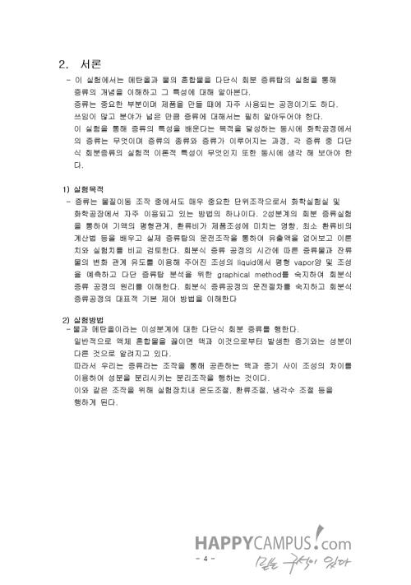

- Biotechnology Laboratory Report
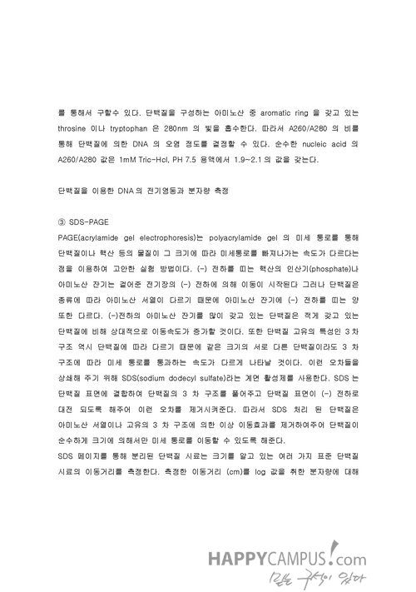

- Civil Engineering Laboratory Report
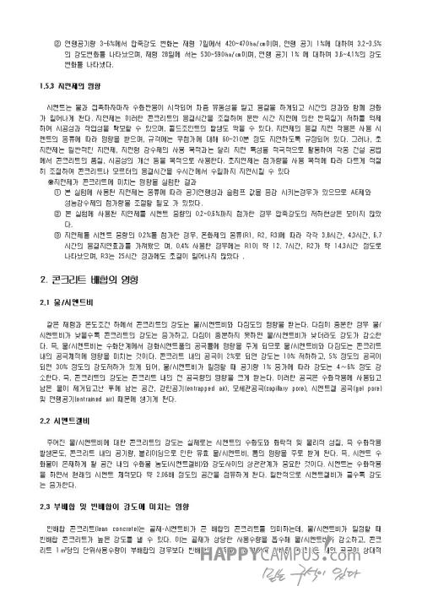

c. How to Prepare a Thesis (Research) Proposal
The research planning stage, which is the initial phase of the research process, is the most important stage in the entire research trajectory. Accordingly, the greatest amount of time and effort is invested at this stage, and in some cases it may take even more time than the actual research execution period. Even the fact that many studies that have contributed significantly to academic advancement and to humanity worldwide spent multiple times more effort on the planning stage than on the actual research process demonstrates how critical the planning stage is. If you avoid rushing during the planning stage and instead prepare with sufficient time and flexibility, the research process is more likely to proceed smoothly, and you will be better positioned to select a more systematic and valid research problem and to obtain meaningful research outcomes.
When writing a research proposal, it is not mandatory to follow one fixed format. However, in general it is necessary to adopt a common structure for effective communication and clarity of reasoning. Depending on the nature of the research problem, certain items in the proposal may need to be described in greater detail, while other parts may be explained briefly or omitted. The key items that should be included in a thesis proposal, and the contents to be included under each item, are as follows.
1) Key Components of a Thesis Proposal
In general, a thesis proposal consists of the following components:
a) Research Topic Title: The research topic of the thesis refers to the task/problem to be solved. The title should be comprehensive yet concise and clear so that the research can be understood from the title alone.
b) Need for the Research: Describe the reasons for selecting the topic, the necessity of addressing it, and its significance. It is advisable to consider the need in terms of both theoretical necessity and practical necessity. In many cases, this is presented together with the purpose of the research.
c) Purpose of the Research: Clearly state what you aim to discover or clarify through the research.
d) Significance (Contribution): Explain what aspects of theoretical or methodological advancement the study can contribute to by solving the research problem, and why those contributions are important. Practical contributions that may be achieved should also be included.
e) Theoretical Background: Systematically present existing principles, laws, and theories relevant to the research topic in an integrated manner. Based on prior research findings, critically examine them and clearly articulate the logical relationship between your study and the relevant theories/laws and the logical relationship between your study and prior studies. Within these relationships, clarify the theories and assumptions that form the foundation for solving your research problem.
f) Formulation of Hypotheses: A hypothesis is a tentative answer to the research topic and is a statement describing a relationship between two variables. This tentative answer should be formulated based on theory or prior research findings. Hypotheses should be stated so that their truth can be determined probabilistically based on empirical evidence.
g) Research Methods: Specify how you will address the selected research topic. Concretely, clarify who will do what and how, and describe the research procedures, research subjects, instruments, data collection, analysis, and processing methods. Depending on the nature of the research task, you may adopt either a literature-based approach or an empirical approach.
h) Expected Results: State what outcomes you expect from the research and outline a tentative conclusion based on those expectations.
i) References: Summarize and organize the topic-related literature that you have obtained or can obtain so that your academic advisor or examiners can help identify any missing sources.
j) Appendix: Provide an outline of the study organized as a table of contents, as well as various instruments and baseline materials to be used in the research.
2) Writing Guidelines by Key Component
a) Research Topic
In the thesis proposal, the research topic to be addressed must be described clearly. In the initial introduction of the topic, first present it at a general level using everyday language; then specify it further by formulating several concrete research objectives or hypotheses. At this stage, the proposed research objectives or hypotheses must be stated clearly and precisely, to the extent that anyone can fully understand exactly what methods or information would be required to solve the problem.
In addition, to demonstrate the validity of the research purpose or the hypothesis formulation, the proposal should include an item that concisely explains the need for the research, the historical background of the research problem, or its theoretical basis. In field-based studies where there are no related prior studies or no established theoretical background, the focus is on resolving an immediate practical problem; therefore, the discussion of the need for the research should be emphasized. In such cases, rather than formulating hypotheses, it is often more appropriate to present several specific research objectives.
By contrast, when the research is not aimed directly at solving an immediate practical problem, and the starting point is grounded in a theoretical basis related to prior research, it is appropriate to express the research topic as hypotheses that are naturally derived from that theoretical framework. In such cases, the proposal should include content or sections emphasizing the theoretical background that supports the hypotheses established through a review of relevant prior research.
b) Research Methods
First, an overall explanation is required of the approach to be used to solve the proposed task. In other words, it is necessary to provide a detailed description of the research methods and procedures, the primary strategies and techniques for problem solving, the experimental plan, measurement instruments, and the sequence of research activities. In some cases, if the application of a specific research method requires particular assumptions, those assumptions must be stated explicitly. In addition, the justification for whether the experimental design or the adopted research methods are appropriate for the research purpose must also be presented.
However, in addition to these general statements regarding the overall research methodology, depending on the nature and needs of the research, you should separately define and describe the following items in detail so that the validity and procedures of the research methods are clearly understood.
① Data Content and Instruments
Depending on the nature of the research and the importance of the research methods, describe the data collection method, experimental procedures, and the characteristics of the measurement instruments. In addition, in experimental studies where certain tools are used or constructed, specify the description of the tools or experimental apparatus, their implementation status and conditions, and the experimental plan.
② Data Processing and Analysis Methods
Specify the statistical methods or analytical methods to be applied to data processing. The analytical method should be considered in advance, before data collection. If, after collecting data at considerable cost and effort, you discover that no statistical method exists that is suitable for the research purpose you aim to address, substantial losses may result.
d. References
1. Kang, Myeong-gu, Kim, Hui-jun, Jeong, Yun-seok, et al. (2008). Scientific and Technical Writing. Seoul National University Press.
2. Kim, Beom-gi, Han, Cheol-woo, & Min, Chan-gyu. (1996). A Study on the Format of Graduate Theses. Research Report, Education Research Institute, Korea National University of Education.
3. Kim, Hyeong-sun. (2005). Revise Only 10% of Your Paper!. Yas Media.
4. Kim, Hyeon-cheol. (n.d.). Guidelines for Thesis Writing. Department of Computer Education, College of Education, Korea University. Retrieved March 25, 2009, from http://comeu.korea.ac.kr/~hkim/
5. Moon, Su-baek. (2003). Practical Research Methods for Writing a Degree Thesis. Hakjisa.
6. Park, Jun-sik. (2008, September). Special Lecture on Writing a Degree Thesis. Department of Library and Information Science, College of Social Sciences, Keimyung University. Retrieved from http://jspark.kmu.ac.kr
7. Park, Chang-won, Kim, Seong-won, & Choi, Seok-du. (1999). Research Methods and Thesis Writing. Ewha Womans University Press.
8. Son, Seok-ju. (n.d.). Guidelines for Thesis Writing. Department of Preventive Medicine, College of Medicine, Chonnam National University. Retrieved March 25, 2009, from http://www.richis.org/html/research/treatise/a06.pdf
9. Lee, Jong-seung. (2006. 2006). How to Write a Research Paper. Seoul: Gyoyookgwahaks.
10. Graduate School of Education, Cheongju National University of Education. (n.d.). Thesis Writing Guide.

Ⅲ. Research Methodology for Humanities Master’s/Doctoral Theses/Dissertations
1. Guidelines for Thesis/Dissertation Writing
a. a. Concept of a Thesis/Dissertation
A thesis/dissertation is a structured academic work in which the author presents research findings, opinions, and arguments on a given topic in a consistent form and in accordance with logical reasoning. In English, it may be referred to as a thesis, a dissertation, or an academic paper. The term thesis is derived from the Greek θέσις, meaning an intellectual proposition, and dissertation originates from the Latin dissertātiō, meaning a discourse or presentation. Theses/dissertations include: Master’s/Doctoral Theses/Dissertations written to obtain academic degrees such as a master’s or doctoral degree, academic papers published in journals or presented at academic conferences, and papers prepared for publication (KIWI: Keynotes of Wikimedia, 2008).
A Master’s/Doctoral thesis/dissertation is produced after completing a prescribed academic curriculum; based on knowledge acquired in the relevant discipline, the student conducts research in an area of interest and systematically organizes and presents the results. Because a thesis/dissertation serves as an official means of articulating one’s academic perspectives and positions, it is highly valuable not only for an individual’s scholarly development but also as a source of academic material for subsequent researchers.
To write a high-quality thesis/dissertation, one must give careful consideration to topic selection, research methods, and academic contribution. More specifically, the conditions of a good thesis/dissertation may be summarized as follows. First, the research topic and content should demonstrate originality. A study that merely repeats prior research is unlikely to be regarded as valuable; therefore, the research content and methodology should be as distinctive and innovative as possible. Second, the research method must be appropriate. The researcher should select and implement suitable research targets, procedures, and methods that align with the topic and content of the study. Third, clarity and objectivity of expression are essential. The statements in the thesis/dissertation should be grounded in accurate and objective results; introducing excessive subjectivity or presenting ambiguous claims undermines credibility. Fourth, the thesis/dissertation should make an academic contribution. A thesis/dissertation becomes meaningful and valuable when it contributes to the advancement of scholarship and can be applied or utilized in real-life contexts.
The thesis/dissertation process should follow a systematic procedure. In general, writing a thesis/dissertation involves selecting a topic, establishing a plan (including research methods and research design), collecting data, analyzing and interpreting the collected data, and finally drafting the thesis/dissertation. These procedures and methods are presented in detail in “Ⅱ. Fundamentals of Research Methodology.”
Because a Master’s/Doctoral thesis/dissertation is an academic report rather than a personal statement, it must be written in accordance with formal academic conventions. In general, a thesis/dissertation consists of elements such as the title, table of contents, summary, introduction, research methods, results, conclusion, references, appendices, and an English abstract (Abstract). The detailed structure, format, and writing requirements are presented in the following sections.
b. Structure and Organization of the Thesis/Dissertation
1) Components of a Thesis/Dissertation
a) Title: The title represents the entire content of the thesis/dissertation and should convey the essence of the work in the most concise and inclusive manner. The title may also reflect key characteristics of the thesis/dissertation, such as the research method and research subject/participants. Points to note when writing the title are as follows:
First, the title should be stated briefly and clearly.
Second, it should be specific enough to reveal the content of the thesis/dissertation unambiguously.
Third, it may be written so that the research method used and/or the research subject is apparent.
Fourth, a subtitle should be avoided where possible; if unavoidable, it should be written after a colon (:).
b) Table of Contents
The table of contents enables the reader to view the overall content, structure, and organization of the thesis/dissertation at a glance. There is no single fixed format or order; it may vary depending on the nature of the research. When preparing the table of contents, it is effective to make the overall flow of the study and the research topic clearly visible. In addition, the numbering used in the table of contents should follow the same numbering system used for chapters and sections as presented below. For an example of a thesis/dissertation table of contents, refer to <Example 7> in the appendix.
c) Summary
A thesis/dissertation summary is a brief condensation of the entire work so that the reader can readily grasp the content without reading the full text. For an example of a Korean-language summary, refer to <Example 6> in the appendix. General guidelines for writing a summary are as follows (Kim Beom-gi, Han Cheol-woo, & Min Chan-gyu, 1996):
First, the summary must accurately present the content and purpose of the study; however, it must not include matters that are not established in the thesis/dissertation.
Second, it should be as concise and clear as possible, minimizing unnecessary content. Sentences should deliver the maximum amount of information in the most economical form.
Third, the summary should be consistent, readable, and include key words. Keep in mind that the summary, together with the title, is used for indexing and retrieval in information searches.
Fourth, the summary alone should sufficiently define the meanings of terms, abbreviations, and acronyms used in the thesis/dissertation; if quotations are included, their sources must also be provided.
d) Introduction
The introduction includes the researcher’s rationale for conducting the study, the necessity of the study, the study purpose, research questions, definitions of key terms, and limitations of the study. When describing the necessity of the study, the researcher should articulate the value and need for the study in terms of theory, research methods, utilization, and application. When stating the purpose, the researcher should describe concretely what they ultimately seek to obtain through the study. Research questions should specify the issues that must be analyzed, demonstrated, or verified on the basis of the study purpose.
e) Theoretical Background
The theoretical background provides the grounds for the research purpose and research questions and should present relevant literature and prior studies in a systematic manner. Rather than listing general and broad theories from the past, it is more effective to focus on theories directly related to the purpose and questions of the present study, as well as recent research and trends. When writing the theoretical background, it should center on directly relevant findings.
f) Methods
The description of methods varies by research type. For experimental and survey research, the methods section describes the research subject/participants, research instruments, intervention/treatment methods, data collection and analysis methods, and research procedures. For data-analysis research, it describes the data analyzed, the scope/content of analysis, and analysis methods. For qualitative research, it describes the research participants, data collection and analysis methods, and research procedures.
g) Results
Results are written on the basis of analysis of the research data. In principle, the results should be presented in the same order as the research questions or hypotheses, describing each corresponding finding. However, the manner of reporting results differs by research type. In experimental and survey research, results are presented primarily through the outcomes of data processing, with tables or figures used where appropriate and explained in the text. In qualitative research, results are described around the meanings that emerged from the study, and excerpts from interviews or observations may be partially inserted to aid understanding. Results should be written objectively, excluding subjective opinions.
h) Conclusion
The conclusion may include discussion, conclusions, and suggestions/recommendations. The discussion is the section in which the researcher may present interpretive perspectives on the results, compare them with prior studies or established theories, and explain noteworthy findings. The conclusion is not a mere repetition of results; rather, it sets out the researcher’s final judgment based on the study findings. Depending on the thesis/dissertation, suggestions/recommendations may be included, describing future research directions and areas for improvement based on the results.
i) References
The references section identifies the sources of all materials that were cited directly or indirectly throughout the thesis/dissertation. Detailed methods for writing references are presented later.
j) Appendices
Appendices present materials not fully included in the methods or results sections, such as test instruments, questionnaires, interview items, or supplementary materials, assigning them consecutive numbers.
k) English Abstract
The English abstract is written in English and, like the Korean summary, focuses on the study purpose, methods, and results. The English abstract should not exceed two pages; refer to <Example 14> in the appendix.
2) Structure and Numbering of Chapters and Sections
a) Hierarchy of Chapters and Sections
Each chapter should be at the same level. A section should be narrower in scope than a chapter and should be composed of subordinate content, so that chapters, sections, subsections, and items form a clear hierarchy and structure. To this end, the titles of chapters, sections, and subsections should be selected appropriately. Chapter and section titles should not be abstract or purely formal; rather, they should contain specific and substantive content so that, even by looking only at the chapter and section titles, the reader can roughly infer the overall content of the thesis/dissertation.
The numbering system for chapters, sections, subsections, and items is as follows: Ⅰ, 1, 1), (1), ①. Examples of the numbering system are as follows:

<Examples of the numbering system>

Ⅰ. Ⅱ. Ⅲ. ...
1, 2, 3, ...
1), 2), 3), ...
(1), (2), (3), ...
①, ②, ③, ...

b) Page Numbers
Page numbers for the entire thesis/dissertation are assigned in two formats. For the Summary, List of Tables, List of Figures, List of Photographs, List of Symbols, etc., use lowercase Roman numerals (ⅰ, ⅱ, ⅲ, etc.). From the Introduction through the main body and Conclusion to the Appendices, use Arabic numerals (1, 2, 3, etc.). Place the page number at the bottom center.
The Summary, List of Tables, List of Figures, List of Photographs, and List of Symbols are paginated separately. In addition, when a new chapter begins, it should start on a new page.
c. Sentences and Writing Style
1) Sentence Expression and Structure
Sentence expression should be written in accordance with the required format, taking into account sentence length, grammatical appropriateness, and logical coherence. Specific points to note when composing sentences are as follows.
a) Conciseness
Concise sentences facilitate understanding of the thesis/dissertation. Accordingly, it is advisable to keep sentences short and to use simple sentence structures, while avoiding unnecessary elaboration or repetition.
b) Plainness
Use ordinary and easy-to-understand language, and avoid excessive emphasis or negation. There is no need to overuse loanwords or Sino-Korean expressions. Also avoid excessive use of adjectives and adverbs, and refrain from extreme expressions, categorical assertions, or superlative modifiers.
c) Consistency
Sentences and paragraphs should maintain thematic unity. Writing style should also be consistent throughout the entire thesis/dissertation. Frequently used words and expression patterns should likewise be used consistently throughout.
d) Cohesion
When the content changes, start a new paragraph; however, write so that the preceding and following paragraphs connect naturally. Each paragraph should consist of at least two sentences. Conjunctions (e.g., therefore, thus, however, but, accordingly) may be used when necessary, but overuse of conjunctions is not desirable.
e) Accuracy
Sentence expression should be free of grammatical errors, and the use of academic terminology should be accurate. Pay careful attention to spelling and usage, and confirm the precise meaning of academic terms before using them.
f) Logical Coherence
Sentences should be logically well-structured. When focusing intensely on research, writers may sometimes produce subjective statements that have not been verified. Because a thesis/dissertation must maintain objectivity and logical coherence, strive to express content objectively.
2) Tense
In principle, present and past tenses are used most frequently, but the future tense may be used depending on the case. Specific usage is as follows.
a) Present Tense
Use the present tense when citing established/general theories. It is also used when defining concepts and terms, and when stating the researcher’s opinion in the Discussion section.
b) Past Tense
Use the past tense when citing findings from prior studies. It is also used when describing the research methods and when summarizing results.
c) Future Tense
The future tense may be used when stating hypotheses and when making recommendations based on research findings. Examples of tense usage are as follows:

<Examples of tense usage>

• Present tense
-Defining a concept
“An image refers to the composite of mental imagery that exists in one’s mind—such as memories, preferences, evaluations, attitudes, emotions, and thoughts—regarding an object or a person. An image has metaphorical implications that include mental representation, visual preference, experiential meaning, context and history, and the expression of potential.”

-Discussion
“Early childhood teachers should strive to form a professional image.”

• Past tense
-Describing methods
“The participants in this study were 228 teachers and 458 children from the Seoul, Gyeonggi, and Chungcheong regions.”

-Describing result
“Early childhood teachers and children held an image of early childhood teachers as both beautiful and active.”

3) Person and Honorifics
a) Person
In general, write in the third person. Instead of “I” or “we,” third-person terms such as “the author” or “the researcher” are appropriate.
b) Honorifics
Do not use honorifics or polite speech. However, when quoting directly, retain any honorifics or polite forms used in the quoted text as-is.
4) Loanwords
Where possible, translate loanwords into Korean. If the translated term is unfamiliar or highly specialized, provide the original term in parentheses. Provide the original term only once (at first mention); thereafter, use only the translated term. When using the original language, write all words in lowercase except for proper nouns. If translating a term would distort its meaning, write the term in Korean as a phonetic rendering and provide the original term in parentheses. For personal names, write Korean names using both family name and given name. For foreign names, use only the family name.

<Examples of loanword notation>

• Translating and providing the original term (when unfamiliar)
Phenomenology

• Writing the original term as pronounced and providing the original term
(image)

• Writing a foreign person’s name
Mitchell

5) Abbreviations, Symbols, and Numbers
a) Abbreviations and Symbols
Because repeatedly using long words and terms can be cumbersome, generally recognized foreign terms may be used in abbreviated form. If an abbreviation in a foreign language is difficult to understand, provide the original term (full form) in parentheses. However, in Korean writing, the principle is to avoid abbreviations as much as possible. Statistical symbols such as M (mean), SD (standard deviation), and t-test may be used as abbreviations.

<Examples of abbreviations and symbols>
• Commonly known abbreviation YWCA
YWCA

• Abbreviation that requires clarification
ASCU(Association of State Colleges and Universities)

• Statistical symbols
M (mean), SD (standard deviation)

b) Numbers
In principle, use Arabic numerals. Numbers less than 10 may be expressed as cardinals (one, two, three), and when indicating order/rank, ordinals (first, second, third) may be used. For units of quantity (e.g., amount, length, distance), use SI units whenever possible.

<Table 1> SI Base Units

Quantity | Unit name | Symbol
Length  Mass  Time  Electric current  Temperature  Amount of substance  Luminous | meter  kilogram  second  ampere  kelvin  mole  candela | m  kg  S  A  K  mol  cd

d. Tables and Figures
Using tables or figures in a thesis/dissertation can be effective because they allow reference materials and results to be presented concisely and clearly. Types of tables and figures may include tables showing statistical data, charts and graphs (e.g., bar graphs, pie charts), diagrams, maps, and various illustrations.
1) Tables
Because tables must be accompanied by interpretation or explanation, it is effective to present each table together with the relevant discussion. Each table must be assigned a sequential table number, and the table number and title should be placed above the table. Units (e.g., %, KRW) shall be indicated at the upper-right of the table. If a table has a source, the source should be provided at the bottom of the table. An example of a table is as follows.

<Example of a table>

<Table 1> Teachers’ Understanding of the Integrated Education and Care Curriculum Unit: %(n)

Category | Know very well | Know to some extent | Do not know well | Do not know at all | Total
Childcare center teachers | 2.4 | 69.6 | 27.2 | 0.8 | 100.0(125)
Kindergarten teachers | - | 64.9 | 34.5 | 0.6 | 100.0(174)
Elementary school teachers | 17.6 | 46.6 | 31.1 | 4.7 | 100.0(148)

Source: Korea Institute of Child Care and Education (2008). A Study on Linkage Measures between the Early Childhood Education and Care Curriculum and the Elementary Education Curriculum.

2) Figures
Because figures must be accompanied by interpretation or explanation, it is effective to present each figure together with its caption and relevant discussion. Each figure must be assigned a sequential figure number, and the figure number and title should be placed at the bottom center of the figure. An example of a figure is as follows.

<Example of a figure>
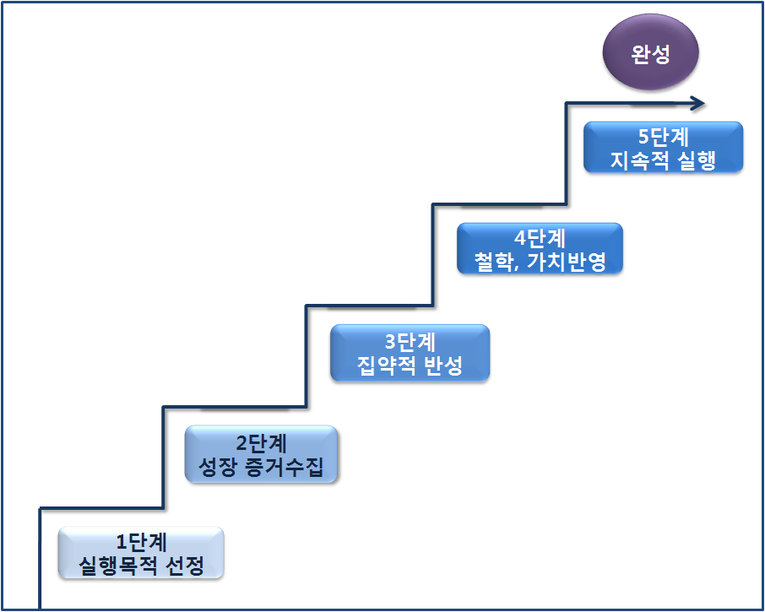

<Figure 1> Stages of a Teacher Portfolio

e. Citations and Notes
In a thesis/dissertation, citations and notes should be presented in accordance with a prescribed format. If sources are not properly cited, not only does it raise issues of research ethics, but it may also result in copyright problems.
Citation and note styles vary across academic communities and disciplines; for Master’s/Doctoral Theses/Dissertations, follow the style specified by the institution and/or department. Citations and notes must be consistent throughout the entire thesis/dissertation and must be accurate in all cases.
1) Citations
Citing refers to incorporating a scholar’s writing into a thesis/dissertation in a prescribed form. Although the researcher primarily presents their own ideas, they also examine prior studies and literature and may use the content presented in those sources. When using content from other studies or literature, it is necessary to clearly indicate whether the content reflects the researcher’s own claim or another scholar’s claim. Because the effectiveness of citation can influence the overall quality of a thesis/dissertation, it is an important component of academic writing. In all cases, sources must be identified, and depending on the material, permission from the copyright holder may be required. Citations can be classified into direct quotations and indirect quotations.
a) Direct Quotations
A direct quotation means reproducing another person’s research or literature verbatim. Direct quotation is appropriate when the original wording is most accurate, when paraphrasing may cause misunderstanding, when quoting formulas, or when highlighting statements that contrast with the author’s position. Specific guidelines for direct quotation are as follows:
① For short quotations under 200 characters (approximately 4–5 lines), use quotation marks (“ ”) or corner quotes (『 』).
② For long quotations of 200 characters or more, present the quotation as a separate paragraph. Leave one line of space above and below the quotation, and distinguish it by using a smaller font size or other formatting; in some cases, a different typeface may also be used.
③ At the end of the quotation, provide the author’s name, year of publication, and the cited page range in parentheses, or add a note.
④ If part of a quotation is omitted, indicate the omission with an ellipsis (...).

<Examples of direct quotation>

• Short quotation
Fride stated that “passion is something that can even be taught, reproduced, and discovered” (Fride, 1995: 6).

• Long quotation
Morgan and Morris stated as follows.

The role of education, when compared with its economic role, may not be greater, but it is at least equally important. Education enables citizens to think and act autonomously and to develop moral and civic consciousness. The quality of education concerns character and competence, and it is related to shaping standards of life and the human spirit (Morgan & Morris, 1999: 16). 16).

b) Indirect Quotations (Paraphrase/Summary):
An indirect quotation refers to summarizing or paraphrasing another person’s research or literature in the researcher’s own words rather than quoting verbatim. Care must be taken not to distort the author’s original intent. Quotations should not exceed half a page. Specific guidelines for indirect quotation are as follows:
① Do not use quotation marks for indirect quotations.
② If the author’s name is not mentioned in the text, provide the author’s name and year of publication in parentheses at the end of the relevant passage.
③ If the author’s name appears in the text, provide only the year of publication, or add a note.
④ When citing multiple sources for a single point, list sources in the order of Korean sources, other Asian sources, and Western sources. Within Korean/Asian sources, order by Korean alphabetical order of author names; within Western sources, order by alphabetical order. Separate sources with a semicolon (;).
⑤ For personal interviews, provide the full name for Korean interviewees; for non-Korean interviewees, provide initials and surname, along with the date of the interview.
⑥ For laws and regulations, provide the name of the law as promulgated and the year of enforcement.
⑦ For secondary citations (re-quotations), provide the original author’s name and indicate the secondary source author and publication year in parentheses to clarify the re-quotation source. In the reference list, include only the secondary source that was actually consulted.
⑧ For translated works, provide the original author’s name, followed by the original publication year and the translation publication year separated by a slash (/). If the original publication year is unknown, provide only the translation year.

<Examples of indirect quotation>

• One author
On this issue, Cho (2001) …
This study suggested that … (Cho, 2001).

• Two authors
Lee and Noh (2003) …
These studies reported that … (Lee & Noh, 2003).

• Three to five authors
-First citation
Lee, Lee, Jung, and Lee (2003) …
Borden, Jones, Smith, Benson, and Corey (2000) …
… (Borden, Jones, Smith, Benson, & Corey, 2000).

-Subsequent citations
Lee et al. (2003) …
Borden et al. (2000) …
… (Borden et al., 2000).

• Multiple sources
Recent studies (Park, 2004; Cho & Lee, 1998; Michael, 1990) indicate that …

• Personal communication
(Hong Gil-dong, personal communication, June 30, 2007)
(J. M. Greene, personal communication, June 17, 1999)

• Laws and regulations
According to Ministry of Education and Human Resources Development Notice No. 15267 (1998) …
National Association for the Education of Young Children(2001)

• Secondary citation
In Kim Young-cheol’s study (1990, as cited in Hong Gil-dong, 2001) …
… was suggested (Kim, 1990, as cited in Hong, 2001).

• Translated book
Regarding free-choice activities, Honig (1981/2001) …

2) Notes
A note is a supplementary explanation that helps readers quickly understand a specific point in the main text.
a) Types of notes
① Source note (reference note): Used to identify the source of material cited or consulted in the text. The format follows the same style as the References list.
② Content note: Used when the author needs to add clarifying or supplemental explanation to the main text.
b) b) Placement of notes
① Footnotes: Notes placed at the bottom of the same page where the referenced content appears.
② Endnotes: Notes collected and presented at the end of each chapter/section or at the end of the thesis/dissertation.
c) Footnote notation
① Footnotes are separated from the main text by a horizontal line and written in a smaller font.
② Insert a small superscript number (or the designated note marker) at the upper-right (or sometimes lower-right) of the sentence; place the same number at the beginning of the corresponding note at the bottom of the page.
③ Numbering may restart on each page, in each chapter, or run consecutively throughout the entire thesis/dissertation.

<Examples of footnotes>

• Source note
Starting Strong recognized the need for continuity in education and proposed an equal and robust partnership between early childhood education and primary education.1)
_______________________________
1) OECD (2006). OECD Early Childhood Education and Care Policy II (Starting Strong II) (translated by the Ministry of Education, Science and Technology and the Korea Institute of Child Care and Education).

• Content note
After World War II, Europe established the Organisation for European Economic Co-operation (OEEC) on April 16, 1948, with 16 Western European countries as members, to accept the U.S. European Recovery Program (Marshall Plan).¹⁾

_________________________________________________
1) The OECD is an intergovernmental forum for economic and social policy coordination among countries that share the values of an open market economy and pluralistic democracy. Its purpose is to promote common stability and prosperity by identifying optimal policy directions for shared issues across economic and social sectors and coordinating member countries’ policies accordingly.

f. References
There is no single fixed method for writing references; formats vary by discipline. In the humanities and social sciences, the APA (American Psychological Association) style is commonly used. Reference-writing rules under APA style include the following.
1) Books
a) Books
For Korean books, list items in the order: author, year, title, place of publication: publisher. For English books, capitalize only the first word of the title (and subtitle, if any) and proper nouns; italicize the book title.
b) Reprinted editions
Following the title, specify the edition in parentheses—(2nd ed.) for Korean books and (3rd ed.) for non-Korean books.
c) Revised editions
For revised Korean books, indicate (Rev. ed.) in parentheses immediately after the title; for non-Korean books, indicate (Rev. ed.).
d) For edited books, list the elements in the following order: author(s), year, chapter/title, editor/translator, book title, page range in parentheses, and publisher. After the editor’s name, indicate the editorial role in parentheses: use (편) for Korean books; for non-Korean books, use (Ed.) when there is one editor and (Eds.) when there are multiple editors.
e) Encyclopedias and dictionaries
For encyclopedias and dictionaries, list: author/editor, year, title, and publisher.

<Examples of Book References>

• Books
Kim, Kyung-Hee. (1995). What is emotion? Seoul: Mineumsa (Minumsa).
Weber, S. & Mitchell, C. (1995). That’s funny, you don’t look like a teacher. Washington D. C.: The Falmer Press.

• Subsequent edition of a book
Cho, Woon-ju, & Choe, Il-seon (Choi, Il-sun). (2005). Guidance for young children’s life in early childhood education institutions (Guidance for children’s life in early childhood education institutions) (2nd ed.). Seoul: Changjisa.
Mitchell, Y. R., & Larwon, J. R., Jr. (1987). People in organizations: An introduction to organizational behavior (3rd ed.). New York: McGraw-Hill.

• Revised edition of a book
Cho, Woon-ju, & Choe, Il-seon (Choi, Il-sun). (2008). Guidance for young children’s life in early childhood education institutions (Guidance for children’s life in early childhood education institutions) (Rev. ed.). Seoul: Changjisa.
Cohen, J. (1977). Statistical power analysis for the behavioral sciences (Rev. ed.). New York: Academic Press.

• Edited book
Ahn, Shin-ho. (1997). The meaning of life sought by working adults (The meaning of life pursued by office workers). In Gim, Myeong-eon (Kim, Myung-eon), & Bak, Yeong-seok (Park, Young-seok) (Eds.), Understanding Korean corporate culture (pp. 388–440). Seoul: Oreum.

Yalom, I. V. (1994). Momma and the meaning of life. In B. Yalom (Ed.), Yalom readers (pp. 155-200). NJ: Prentice-Hall. Hennessey, B. Hennessey, B.
A., & Amabile, T. M.(1999). Consensual assessment. In M. A. Runco, & S. R. Pritzker (Eds.), Encyclopedia of creativity (pp. 347-360). Oval Road, London: Academic Press.

•Encyclopedia/Dictionary
Hong, Gil-dong, et al. (Eds.). (2000). Encyclopedia of early childhood education (Comprehensive encyclopedia of early childhood education) (3rd ed., Vols. 1–9). Seoul: Hangeulsa.
Sadie, S. (Ed.) (1990). The new Webster dictionary of music and musicians (6th ed., Vols. 1-20). London: Macmillan.

2) Periodicals
a) Periodicals
For periodicals, list in the following order: author, year, title, journal title, volume(issue), page range. For English periodical article titles, capitalize the first letter of the first word and write the rest in lowercase, and italicize the journal (society journal) title and the volume number.
b) Articles in magazines and newspapers
For magazine articles, list: author, (year, month), title, issue, pages. For daily newspapers, list: author, (year, month, day), title, newspaper name, pages.

<Examples of References for Periodicals>

• Periodicals
Kim, Jin-young. (2002). A qualitative study on kindergarten block play (A qualitative study of block play in kindergartens). Yua Gyoyuk Yeongu (Early Childhood Education Research), 22(4), 147–172.
Michael, W. B., & Freeman, D. J. (1992). Characteristics of teacher candidates. Educational Research, 62(3), 37-65.

• Articles in magazines and newspapers
Kim, Seon-dal. (1997, July). The greatest joy of my life (The best joy of my life). Joeun Eomma (Good Mom), 12, 82–137.
Lee, Sung-joo. (2000, October 24). A mother’s love is the best medicine (Mom’s love is the best cure). Yua Ilbo (Children’s Daily), p. A6.

3) Translated Books
a) Books translated into Korean
For a book translated into Korean, list: original author, year, translated title, original title (italicized if in English), translator, place of publication, publisher, and present the original publication year in parentheses.
b) Books translated into English
For a book translated into English, place a comma after the translator’s name and indicate “Trans.”

<Examples of References for Translated Books>

Goldstein, L. (2001). Teaching with love: A feminist approach to early childhood education [Sarang-euro gareuchigi]. (Translated by Yeom, Ji-suk (Yum, Ji-sook)). Seoul: Changjisa. (Original work published in 1997)

Laplace, P. S. (1951). A Philosophical essay on probabilities (F. W. Truscott & F. L. Emory, Trans.). NY: Dover. (Original work published 1814).

4) Master’s/Doctoral Theses/Dissertations
a) Domestic/Asian Master’s/Doctoral Theses/Dissertations
For domestic (including Asian) universities, list: author, year, thesis/dissertation title, degree-granting institution, degree.
b) Western Master’s/Doctoral Theses/Dissertations
For Western universities, list: author, year, thesis/dissertation title (italicized), degree, followed by a period, and then the degree-granting institution. For overseas institutions, include the country (for the U.S., include the state).

<Examples of References for Master’s/Doctoral Theses/Dissertations>

Lee, Geum-ran. (2000). A study on the image of kindergarten teachers (A study on kindergarten teachers’ image). Master’s thesis, Graduate School of Education, Ewha Womans University.

Eltiste, W. K. (1989). A study to determine the effects of a supervision training program upon cooperating teachers and student teachers. Doctoral dissertation, The University of Nebraska, Nebraska, USA.

5) Technical/Research Reports
a) Research reports
For research reports, list: researcher(s), year of publication, report title, research institution, report identification number (if applicable), publisher (if applicable).
b) Reports
For Educational Resources Information Center (ERIC) reports, list: author, year, title (italicized), and the ERIC number in parentheses.

<Examples of References for Technical/Research Reports>

Jeong, Mi-ra, Heo, Hur, Hye-kyung, Park, Eun-hye, & Gwon, Jeong-yun. (2007). A study on measures to ensure basic learning competencies in early childhood. Korea Educational Development Institute (KEDI) Research Report, CR 2007-2.

Diamantes, T. (1996). Using portfolio to assessment teacher progress. (ERIC Document Reproduction Service No. ED 405 360).

6) Conference Proceedings
If included in conference proceedings, present the year of presentation in parentheses immediately after the author’s name, followed by a period. Then write the title of the study, followed by a period, and then provide the publication/proceedings title, page range, presentation date(s), and location.

<Example of a Reference for Conference Proceedings>

Yeu, H. (2006). Beyond monologue toward dialogue: understanding a pedagogy of responsibility in postmodern perspectives. *The 4th KSECE International Conference, Transcending modernity in early education and care*, pp. 91–115. October 20–22, Seoul: Seoul Women’s University.

7) Website Materials
For website materials, list: author, year, title, website address, and retrieval year, month, and day.

<Example of a Reference for Website Materials>

National Institute of Korean Language. (2006). *Standard Korean Language Dictionary*. Retrieved March 5, 2007, from http://www.korean.go.kr.

2. Fundamentals of Research Methods
a. Concept of Research
The Standard Korean Language Dictionary defines research as “the act of investigating and thinking deeply about an issue or object, and examining the truth.” (National Institute of Korean Language, 2008). The Dictionary of Educational Terms (1994) defines research as “a careful and critical scholarly inquiry that uses various methods to clarify or solve a problem, broadly divided into literature research and observational research.” Seong Tae-je (1998) defined research as work that establishes theories by verifying evidence through systematic, concrete, and logical methods, rather than relying on unsupported common sense, because research is something conducted by scientific methods. Based on these definitions, research can be understood as a process of investigating, exploring, and verifying issues or objects by employing various methods in order to solve problems.
Those enrolled in master’s/doctoral degree programs conduct research while writing their Master’s/Doctoral Theses/Dissertations, and the following considerations are important for conducting high-quality research. First, to conduct thoughtful research, it is necessary to observe the target or situation being studied diligently and in depth over an extended period. Second, researchers must be trained to avoid bias in data collection and interpretation. Third, research must be carried out systematically in terms of planning and methodology. Fourth, research should be creative and continuously exploratory in order to answer diverse questions (Walsh, 1998, as cited in Hwang, 2004).
Research proceeds through a systematic process, and in most cases it is carried out in the following order: topic selection, research planning and design, data collection, analysis and interpretation, and thesis/dissertation writing. Selecting a thesis/dissertation topic is both very important and difficult. It is desirable for the topic to be one in which the researcher has strong interest and that also aligns with the advisor’s area of interest. A topic can also be derived from prior studies. However, it is necessary to examine whether the topic is sufficiently original and whether research implementation and data collection are feasible. During the research planning and design stage, the researcher must establish a concrete plan regarding research participants/subjects and content appropriate to the topic and purpose, research methods, data collection and analysis methods, and research procedures. Because a wide range of research methods has recently been introduced, selecting an appropriate method—among quantitative research (e.g., survey research, experimental research) and qualitative research (e.g., ethnographic approaches, hermeneutic approaches, case studies)—is particularly important. In accordance with the research plan and design, the researcher collects data while conducting the study. Data collection methods include, among others, document collection, questionnaires, measurement and observation, interviews, focus groups, and the Delphi method. Data analysis varies depending on whether the collected data are quantitative or qualitative, and on whether the researcher intends to quantify results or to describe them. Quantitative data analysis involves coding and quantifying the data and analyzing them using statistical software, whereas qualitative data analysis involves categorizing collected data and interpreting them with a focus on meaning. Detailed research methods, such as research procedures, topic selection, literature review, research types, data collection, and data analysis—are described in the following sections.
b. Research Procedures
To conduct systematic research, it is desirable to proceed through an appropriate process. Most research generally consists of three major stages: planning, implementation, and report writing.
1) Planning Stage
In the first stage, the planning stage, the researcher conducts a literature review, selects a research topic, formulates research questions and research hypotheses, designs the study, and carries out a pilot study. The first task in the planning stage is to select the research topic. A research topic may be identified based on one’s own interests, the advisor’s interests, or practical experience; however, in many cases it is derived from the literature. Therefore, a literature review must accompany the process of selecting a research topic.
Once the research topic has been selected, the researcher must specify detailed research questions that clarify which issues will be addressed. Research questions indicate what will be covered in the research findings, because the findings are reported according to the research questions. After the research questions are set, research hypotheses can be formulated.
When the topic, questions, and hypotheses are established, the researcher must decide whether to conduct quantitative research or qualitative research, determine who the participants will be and how many will be included, and decide how data will be collected and what instruments will be used. The researcher also develops a detailed plan for research procedures, including when to conduct the pilot study and when to implement the main study. Based on this plan, the pilot study is conducted; its issues are analyzed; and the plan for the main study is refined and completed in a more concrete manner.
After the overall research plan is finalized, the researcher prepares a research proposal. Although this may vary by academic field, research proposals are often presented in front of peers, senior/junior colleagues, and faculty members. This process helps identify issues that the researcher may not have recognized and enables revisions, thereby supporting the implementation of a systematic thesis/dissertation. The contents that should be included in a research proposal are as shown in <Figure 1> below.
Title
Ⅰ. Introduction
Ⅱ. Theoretical Background
Ⅲ. Research Methods
1. Research Participants
2. Research Instruments
3. Research Instruments
4. Data Analysis
Ⅳ. Expected Results
Ⅴ. Research Schedule
References
Appendices (Research Instruments)

<Figure 1> Research Proposal Table of Contents Format
2) Implementation Stage
The main study is conducted after revising issues identified in the pilot study. The data obtained from the main study are then analyzed. Depending on the research method, the procedures for data collection and analysis will differ. Specific details regarding data collection and analysis will be addressed later.
3) Report Writing Stage
A research report includes the table of contents, abstract, necessity and purpose, theoretical background, research methods, results, discussion and conclusion, references, and English abstract (Abstract). The research necessity and purpose, theoretical background, and research methods are often drafted during the planning stage; however, it will be necessary to reorganize and revise them systematically in accordance with the research results. For specific matters, refer to the content presented in the guidelines for thesis/dissertation writing. The research procedures described above can be presented in a diagram as shown in <Figure 2> below.

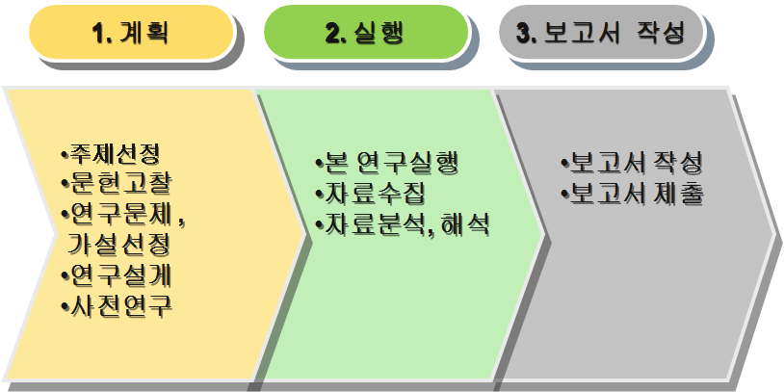

<Figure 2> Research Procedures
c. Research Topic
1) Exploring a Topic
Selecting a thesis topic and research questions during the research process is extremely difficult and also the most important part. A thesis topic should, first and foremost, be something the researcher can take an interest in. However, many students do not clearly recognize their own interests or areas of curiosity, and they often spend a great deal of time searching for a thesis topic. Effective directions for selecting a thesis topic are as follows.
a) Reviewing Prior Research
A researcher’s interests or curiosity do not arise only as vague ideas in one’s mind. Scholars and researchers in the relevant discipline have continuously conducted research, and Master’s/Doctoral Theses/Dissertations in the field are also produced on an ongoing basis. Therefore, reviewing prior research, literature, and major textbooks that have been conducted to date can help the researcher confirm which area they are interested in, obtain good ideas, and identify recent trends and studies that have already been carried out. At the beginning, it is advisable to review prior research in the discipline relatively broadly. At this stage, if reviewing all of the prior research or an entire thesis is too time-consuming, it is possible to focus on the abstract (or summary) and the conclusion and discussion. As the researcher gradually narrows down their area of interest, they can search for prior research accordingly. The more the area of interest is narrowed, the more effective topic selection becomes.
Applying principles presented in recent papers or major textbooks, or applying previously used methods or techniques in a newer way, can become a creative research topic. In the discussion or conclusion sections of prior papers or studies, directions for future research are usually suggested; among them, items that are feasible and of interest can be adopted as one’s own research topic.
b) Considering One’s Own Interests
Although there are various sources from which a thesis topic can be explored, the most important source is the researcher’s own personal interest. Even if other conditions are satisfied, it is difficult to complete the research if it does not align with the researcher’s personal interests. Most research is not completed in a few days or a few weeks; it may take at least several months, one semester, or even more than one year, and therefore it is not feasible to conduct research for a long period on a topic in which one has no interest. Accordingly, the researcher should select a research topic that they can genuinely like and can pursue without losing interest even over a long research process.
c) Considering the Advisor’s Interests
A degree thesis is not a thesis written independently by a student alone; rather, it is conducted under the supervision of an advisor. If a topic is selected that lies outside the advisor’s interests, the advisor may also face difficulty in providing guidance; thus, it is effective to find a research topic that is close to the advisor’s area of interest. In addition, because the advisor is an expert in the discipline, they may have sufficient academically and practically meaningful research topics and may be able to recommend a topic. However, some students proceed with a thesis based on a topic they believe to be of interest without consulting their advisor and later experience difficulties. To prevent such problems, students should consult with their advisor when deciding the thesis topic and research direction.
d) Exploring Practical Problems
A thesis topic can be selected not only through theoretical review, personal interest, or the advisor’s interests, but also from the interests and problems of industry and practice in the relevant discipline (e.g., companies, public institutions, financial institutions, distribution organizations, educational institutions, etc.). Such topics can be more practical and creative research topics. In particular, graduate students with substantial field experience may wisely choose a topic that reflects field needs and can be applied in practice.
However, it should be kept in mind that not every practical problem found in the field can become a thesis topic. No matter how frequently a problem occurs in practice, if it cannot be sufficiently examined through the content studied in the degree program or through the knowledge and theories of the discipline, it is not appropriate as a thesis topic (Cheongju National University of Education Graduate School, 2006).
2) Conditions for a Topic
Selecting a good topic is not a simple task and should be done in consideration of feasibility and various circumstances. The specific conditions of a research topic are as follows.
a) Specificity of the Topic
When initially selecting a research topic, the researcher may review broadly; however, the focus should gradually be narrowed, and ultimately a specific and detailed topic should be selected. If the research topic is too broad, it is difficult to conduct the research, and broad studies do not appear novel or creative. Therefore, a specific topic should be selected even within the area of interest.
b) Creativity of the Topic
A degree thesis is, of course, a student’s thesis; however, insofar as it is an official expression of one’s academic views and position through completing a prescribed curriculum and conducting research activities in an area of interest, its professionalism is recognized. Therefore, rather than imitating existing research and literature, it is necessary to select a creative topic. Of course, because a large amount of prior research has already been conducted, it is not easy to find a topic that is entirely new and creative. Nevertheless, a creative topic can emerge through identifying problems in existing research, changing methods, and related approaches.
c) Considering the Researcher’s Capability
Even if an excellent research topic is selected, the research cannot be completed if the researcher does not have the ability to carry it out. Examples include: a student who is not proficient in Chinese character attempting research that analyzes past history; a student with insufficient foreign-language ability attempting a comparative study across many countries; or a student with insufficient statistical-processing ability attempting research requiring advanced statistical analyses.
In addition, if conducting the research would require excessive research costs, extensive personnel, or if experimental equipment and space cannot be secured, the research cannot be performed. Therefore, when selecting a research topic, the researcher must consider their professional and intellectual capacity as well as economic capacity.
d) Considering the Research Period and Timing
A degree thesis has a submission deadline set by the graduate school. Unlike personal research, the study must be completed within a limited time; therefore, an appropriate research topic that can be handled within the available time frame should be selected. Examples of time-frame issues include: a student who must write a thesis within one semester attempting to analyze the economic trends of a region over the next year, or analyzing one year’s worth of administrative civil complaints. Examples of timing issues include: a student who must write a thesis in the second semester attempting to study young children’s adjustment process at the beginning of the semester, or studying students’ winter vacation life.
Some thesis-writing students fail to consider the research period and timing in advance and end up spending multiple semesters writing a thesis that could have been completed within one semester. Accordingly, it is essential to confirm whether the available research period and appropriate timing align with the research topic.
e) Sufficiency of Data and Materials
A degree thesis is clearly a creative endeavor. However, a degree thesis is research conducted by students who are still in the learning process, and the objectivity of the thesis can be maintained through other scholars’ and researchers’ proposals, writings, and research results. In other words, whether sufficient prior research and literature have been reviewed and reflected throughout the thesis process is also a factor that determines the quality of the thesis. Therefore, sufficient relevant literature and materials are required. Moreover, if the research involves analyzing materials or literature, the target materials or literature to be analyzed must be sufficient and readily obtainable.
3) Selecting a Topic
Based on the sufficient exploration of topics presented above and consideration of the conditions required of a research topic, the thesis topic is selected. Most students begin to think about a thesis topic when the thesis semester begins. However, a good topic does not suddenly come to mind or appear only when the thesis semester arrives; therefore, it is effective to take interest in and think about a thesis topic as early as possible.
Even while taking coursework, it is advisable to continually reflect on which areas are becoming of interest. While taking courses that require writing reports or preparing presentation materials, the student may discover a part that is of interest; deepening such a part and systematically organizing it to develop it into a thesis topic can yield a “two birds with one stone” effect in terms of time, effort, and other aspects. Accordingly, when carrying out assignments for each course, it is also necessary to make one’s best effort with the mindset that the work could become the topic of the degree thesis.
The initially selected topic cannot be perfect and in most cases goes through a process of revision and change; therefore, even if it is incomplete, it is effective to select a preliminary topic and develop it further. When selecting a preliminary topic, it is also wise to begin not with only one topic but with two or three topics of interest and narrow them down. If the process begins with only one topic, there may be cases where the research cannot be carried out due to the research conditions presented above; therefore, it is also good to begin with about two or three preliminary topics.
d. Literature Review
A literature review is necessary to (i) select a research topic, (ii) describe the theoretical background, and (iii) write the discussion. In the case of literature-based research that analyzes documents as research data, the documents themselves become the objects of study. In this way, a literature review is an essential foundational process in research, and it can also constitute core content. Therefore, students with little or no research experience should strengthen the foundation of their research by reviewing a substantial body of literature and prior studies.
1) Importance of the Literature Review
Seong Taeje (1998) presents the reasons for conducting a literature review as follows.
First, by reading studies published up to the present, one can determine how far research has progressed, who conducted what kinds of studies, and what topics remain researchable. It is also possible to verify whether the topic a researcher intends to study has already been published. In addition, through a literature review, the researcher can develop insight into the possibility of integrating the topic with other fields and the future prospects of the topic.
Second, one can identify researchable topics. Many articles published in academic journals or presented at academic conferences mention future research questions after the conclusion, and a research topic may be discovered in this part.
Third, one can specify the research problem. Many researchers fail to carry out research successfully because, despite strong motivation, they do not conduct a thorough literature review, resulting in research problems that are general and abstract. Through a literature review, such abstract research problems can be specified and delimited to a particular area.
Fourth, one can explore new approaches. For example, after reading an experimental study that used a particular treatment method, a researcher may design a study using a different treatment method. Likewise, changing the research participants and analyzing the results can also constitute a new approach.
Fifth, one can gain insight into research methods. By understanding which participants prior studies examined and what methods and procedures they employed, the researcher can make more informed choices about research methods.
Sixth, one can avoid trial and error that may occur during the research process. In research articles, the section on limitations can help the researcher anticipate potential issues and prevent them in advance when conducting their own study.
2) Scope of the Literature Review
In Master’s/Doctoral Theses/Dissertations, what must be reviewed is not fixed; the scope and targets of the literature review may vary depending on the research topic. In general, the review includes books related to the topic. Because books organize fundamental concepts and related theories well, they can be used when defining terms and presenting foundational theories in the theoretical background. In addition, the review covers domestic and international Master’s/Doctoral Theses/Dissertations and articles published in domestic and international academic journals. Through theses/dissertations and journal articles, the researcher can identify recent research trends and understand and utilize research methods and instruments. Other resources may include electronic journals, dictionaries/encyclopedias, newspaper and magazine articles, and internet materials. Newspaper articles, magazines, and internet materials should be used cautiously, considering that their quality may not have been academically vetted.
3) Methods of Conducting a Literature Review
In the past, because computers were not used, researchers had to visit libraries in person, review subject index cards one by one, and locate relevant books, articles, and research reports. Today, most literature can be searched online, and in many cases full texts can be downloaded or printed. Methods of conducting a literature review via the internet include the following.
First, when reviewing literature, search for materials using the key words of the topic. If too many relevant articles are retrieved, use more specific key words, or re-search within the retrieved results using more specific key words.
Second, locate articles relevant to the topic and, if free full-text printing and downloading are available, download them to a computer and review the content. If access is paid, request document delivery/copying or pay the fee to view the material.
Third, literature searches can be conducted through various information-service sites. Through the homepage of the Korea National University of Transportation Central Library, it is possible to search not only holdings but also domestic electronic journals and overseas journals, and to download or print full texts. Through RISS (Research Information Service System), an academic information service provided by the Korea Education and Research Information Service (KERIS), one can also search journal articles, theses/dissertations, books, and overseas journal articles and theses/dissertations.
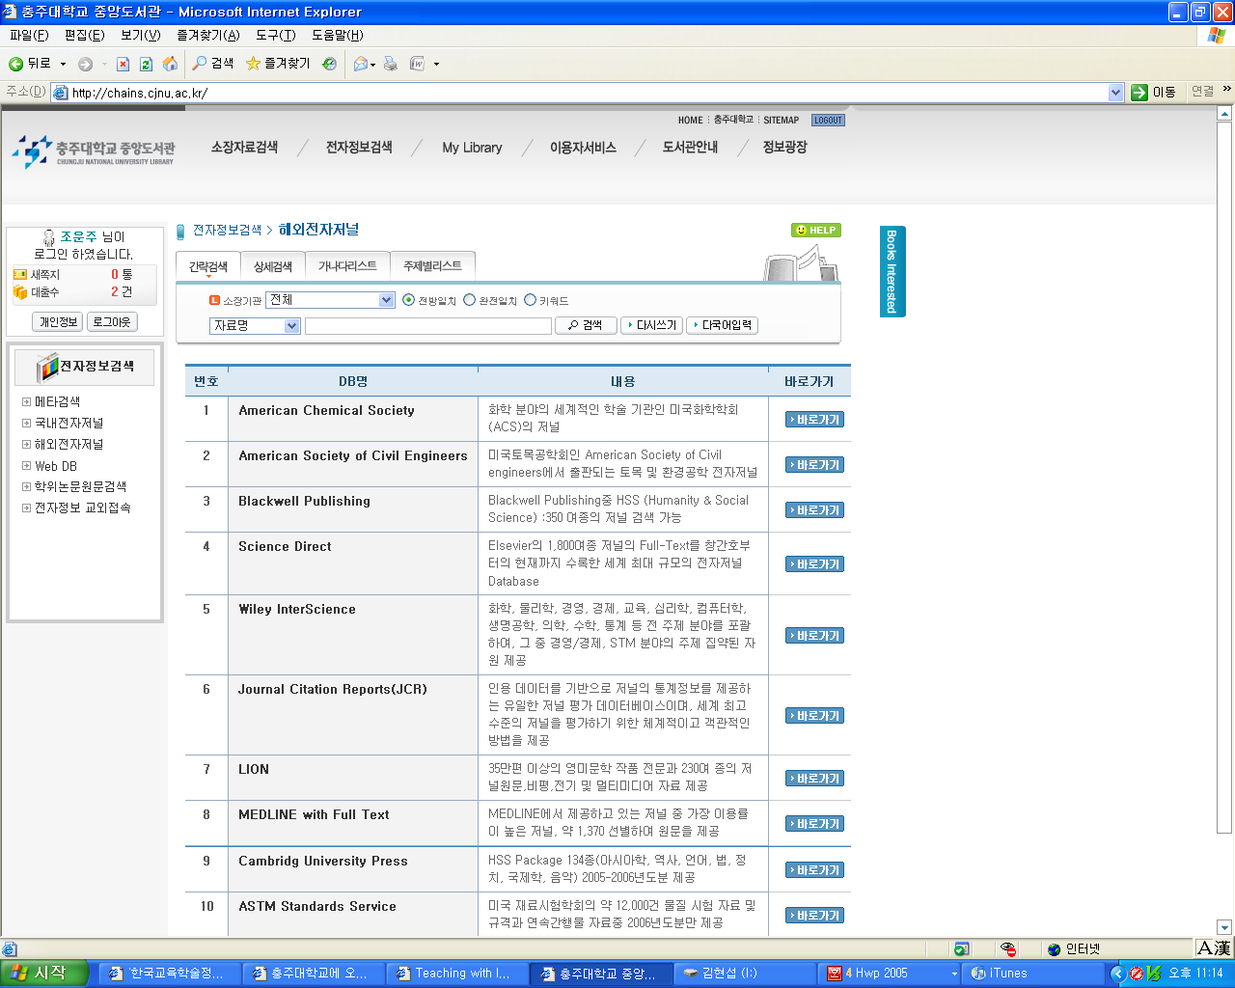

<Figure 3> Overseas Electronic Journal Search Window of the Korea National University of Transportation Library
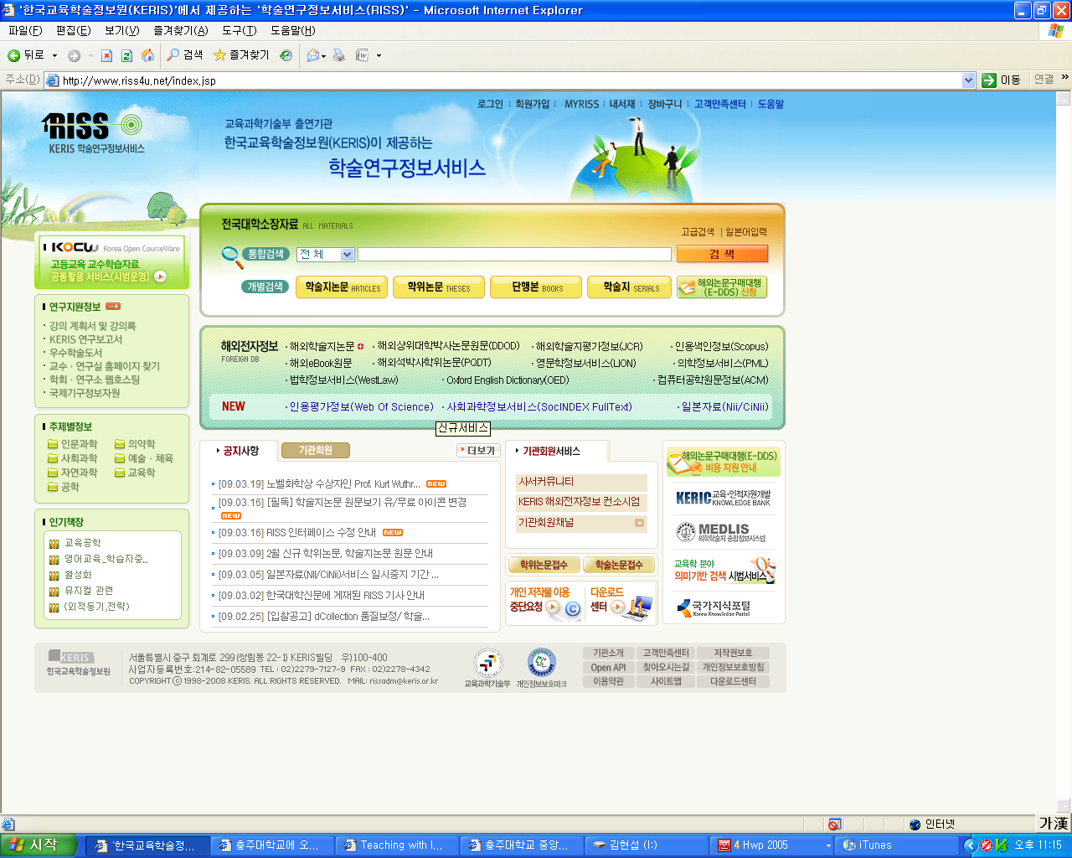

<Figure 4> Holdings Search Window of the Korea Education and Research Information Service (KERIS)
e. Research Types
The criteria for classifying research types vary depending on purpose, method, and form. Depending on the research method, research can be classified into descriptive research, experimental research, action research, ethnographic research, and historical research. It can also be divided into quantitative research and qualitative research according to research logic and techniques. In recent years, there has been a strong tendency to classify research into quantitative research and qualitative research. The differences between quantitative and qualitative research are as follows (Glesne & Peshkin, 1992: re-cited from Lee Hyeokgyu, 2005).

<Table 1> Comparison of Characteristics of Quantitative and Qualitative Research

Category | Quantitative Research | Qualitative Research
Basic Assumptions | ⦁ Social facts are objective.  ⦁ Research methods take priority.  ⦁ Variables can be measured and controlled.  ⦁ Emphasis on the outsider’s perspective. | ⦁ Reality is socially constructed.  ⦁ Research topics take priority.  ⦁ Variables are complex and interconnected, making them difficult to measure.  ⦁ Emphasis on the insider’s perspective.
Purpose | ⦁ Generalization  ⦁ Prediction  ⦁ Causal explanation | ⦁ Contextuality  ⦁ Interpretation  ⦁ Understanding the actor’s perspective
Approach Methods | ⦁ Hypotheses and theories precede the study.  ⦁ Manipulation and control  ⦁ Use of formal instruments  ⦁ Experimentalism  ⦁ Deductive  ⦁ Factor analysis  ⦁ Exploration of consensual norms  ⦁ Quantification  ⦁ Abstract language | ⦁ Discovery of hypotheses and grounded theory  ⦁ Generation and description  ⦁ Researcher as instrument  ⦁ Naturalistic  ⦁ Inductive  ⦁ Exploration of patterns  ⦁ Exploration of pluralism and complexity  ⦁ Non-quantification  ⦁ Concrete language
Researcher’s Role | ⦁ Distancing and fairness  ⦁ Objective description | ⦁ Personal participation and partisanship  ⦁ Empathic understanding

1) Quantitative Research Methods
a) Survey Research (survey research)
① Concept
Survey research is a research method used to identify and analyze the current state, namely phenomena, rather than to analyze causes and effects. Survey research examines facts by identifying phenomena through questions in uncontrolled, natural settings (Seong Taeje, 1998).
② Types
Survey research can be designed in different ways depending on research purpose, time perspective, duration, and participants (Lee Hyekyung, Yang Younghee, Gu Miok, Eun Young, 1995). The design types are presented in <Table 2> below.

<Table 2> Survey Research Design Types

Classification Criterion | Design Type | Characteristics
Research Purpose | Descriptive survey | Observes and records phenomena and does not discuss relationships among variables.  Example) Degree of obesity among elementary school students
Research Purpose | Explanatory survey | A study that seeks to understand differences in concepts or relationships.  Example) Comparing stress between employed homemakers and full-time homemakers
Research Time Perspective | Retrospective survey | A survey that links a current phenomenon to a different phenomenon in the past.  Example) Relationship between smoking history and incidence of lung cancer
Research Time Perspective | Prospective survey | A study that investigates an assumed cause and analyzes the assumed outcome through the research.  Example) Relationship between milk intake in early childhood and height
Research Duration | Cross-sectional survey | Collects data at one point in time (simultaneously).  Example) Analysis of stock investment experience among business administration students
Research Duration | Longitudinal survey | Collects data by measuring the same participants at multiple time points.  Example) Patterns of change in teaching efficacy as early childhood education majors advance to higher grades
Participants | Sample survey | Conducts research by selecting a sample that represents the population.  Example) Current status of kindergarten–elementary articulation education
Participants | Large-scale survey | Collects information from a large sample.  Example) Opinion polling during a presidential election
Participants | Census survey | Targets the entire population.  Example) Population census

③ Research Procedure
In survey research conducted through questionnaires or interviews, it is difficult to carry out scientific research unless the research procedure is established systematically. A general research procedure for questionnaire-based survey research is as follows (Seong Taeje, 1998).
First, specify the research purpose.
Second, select the research participants and identify the sampling method.
Third, draft an information sheet (cover letter).
Fourth, develop the questionnaire.
Fifth, conduct a pilot study.
Sixth, analyze and revise the questionnaire.
Seventh, draw the sample.
Eighth, send out the questionnaire.
Ninth, send reminder letters to non-respondents.
Tenth, compile and analyze the response data.
④ Advantages and Disadvantages
An advantage of survey research is that, because data are collected using developed instruments or questionnaires, it requires relatively less time and cost while enabling the collection of information from a large number of participants. However, it also has disadvantages, including a low response rate, a high likelihood of obtaining superficial data, and an inability to determine causal relationships between the study variables and related variables (Lee Eunok, Lim Nanyeong, Park Hyunae, 191).
b) Experimental Research
① Concept
Experimental research involves observing phenomena that occur under socially constructed conditions, that is, conditions intentionally and artificially created; the function of an experiment is to clarify the cause of an event. Accordingly, a true experiment is conducted through procedures such as controlling variables considered to affect the process, manipulating the conditions and levels of the experimental variable, applying interventions and treatments, and comparing results (Shaughnesy & Zechmeister, 1994, as cited in Graduate School of Education, Korea National University of Education, 2006). Experimental research that aims to identify cause-and-effect relationships has three characteristics: manipulation, control, and randomization. These characteristics are presented as follows (Lee Hye-gyeong et al., 1995).
⦁Manipulation
Manipulation refers to the researcher providing an experimental treatment or intervention to the experimental group. The phenomenon that is manipulated is referred to as the independent variable (treatment), and the response to the independent variable is measured as the dependent variable, also called the outcome or effect variable. For example, if one seeks to study young children’s concepts of sex as influenced by sex education, the independent variable is sex education and the dependent variable is the concept of sex.
⦁Control
Control refers to regulating various external factors (extraneous variables) other than the independent variable that may affect the dependent variable. By comparing with a control group (comparison group) that did not receive the experimental treatment, the researcher can determine whether the experimental group’s outcomes are attributable to the treatment.
⦁Randomization
Randomization refers to selecting participants randomly and assigning them to the experimental group and the control group. This is an effort to make the experimental and control groups equivalent.

② Types
Types of experimental research can be classified into true experimental designs and quasi-experimental designs. A true experimental design is one that satisfies all three characteristics of experimental research: randomization, manipulation, and control. If only some of these characteristics are satisfied, the design is considered quasi-experimental. Both true experimental designs and quasi-experimental designs include various specific design methods; because understanding them can require substantial time, it is recommended that students learn them through a graduate-level research methods course.
③ Research Procedure
Experimental research may involve more complex methods and procedures than survey research. Therefore, it is effective to understand and implement the research procedure accurately. Seong Taeje (1998) presents the general procedure as follows.
First, clarify the purpose of the study.
Second, specify the research hypotheses.
Third, identify the treatment variable, dependent variable, and mediator variables, and examine their characteristics.
Fourth, select the research participants.
Fifth, develop or select instruments to measure changes in the dependent variable.
Sixth, conduct a pilot study.
Seventh, eliminate problems identified in the pilot study.
Eighth, select participants for the main study.
Ninth, conduct the experiment.
Tenth, collect data.
Eleventh, analyze the results.
④ Strengths and Limitations
True experimental designs are the most effective method for identifying causal relationships; however, in practice, it is often difficult to conduct research while meeting the conditions of randomization, manipulation, and control. Moreover, in social-science research involving human participants, it is often impossible to implement a perfectly true experimental design. In contrast, quasi-experimental research can be conducted in natural settings that are not artificially manipulated, but it has difficulty in reliably controlling various extraneous variables.
2) Qualitative Research Methods
a) Ethnography
① Concept
Ethnographic research is grounded in anthropology, which scientifically investigates human development and change. Ethnographic research examines topics such as a people’s culture, customs, folklore, religion, beliefs, values, norms, and language. It shows how people within a particular culture define the world in which they live. Seong Taeje (1998) stated that ethnographic research has phenomenological, naturalistic, holistic, and iterative characteristics. The phenomenological characteristic refers to studying phenomena, with an emphasis on describing naturally occurring phenomena. The naturalistic characteristic refers to conducting research in settings as they are, without artificial manipulation. The holistic characteristic refers to analyzing not a single part but all occurring phenomena in an integrated manner. The iterative characteristic refers to the absence of predetermined hypotheses; instead, the formation and verification of hypotheses are repeated throughout the research process.
② Research Procedure
Compared to other research approaches, ethnographic research has an integrated research procedure. The general procedure of ethnographic research is as follows (Seong Taeje, 1998).
First, identify the phenomenon to be studied.
Second, select the research participants.
Third, develop a general hypothesis related to the research purpose.
Fourth, collect data through in-depth interviews and participant observation.
Fifth, analyze the data.
Sixth, derive the conclusions of the study.
b) Phenomenological Research (phenomenological research method)
① Concept
Phenomenology explores the essence of phenomena as experienced by people; it investigates individuals’ experiences of a given phenomenon and their interpretations of those experiences. Phenomenology aims to reveal and describe lived experience and has the following specific purposes (Seong Taeje, 1998).
First, to clarify the essence of being human.
Second, to expand awareness.
Third, to demonstrate that the construction of reality is accomplished by humans.
Fourth, to strengthen the close connection between theories and concepts and actual lived experiences.
② Research Procedure
The research procedure for phenomenological research is the same as that for ethnographic research. Specifically, it is as follows.
First, identify the phenomenon to be studied.
Second, select the research participants.
Third, develop a general hypothesis related to the research purpose.
Fourth, collect data through in-depth interviews and participant observation.
Fifth, analyze the data.
Sixth, derive the conclusions of the study.
f. Data Collection
Methods of data collection broadly include questionnaires, interviews, telephone surveys, and observation. Each method is described in detail below.
1) Questionnaire Method
a) Concept of the Questionnaire Method
The questionnaire method is a data-collection method in which the researcher collects data by having research participants answer questions. There are several ways to administer questionnaires, including: sending and collecting questionnaires by mail; delivering and collecting them through in-person visits; sending and collecting them via email; and having participants respond through the internet. In the past, mail and in-person visits were commonly used; however, with the development of the internet, questionnaires are increasingly administered via email or through online platforms.
Distributing and collecting questionnaires by mail is appropriate for participants located across a wide geographic area and for participants who cannot use the internet. However, this method has drawbacks, such as a low return rate and the inconvenience of relying on postal returns. To increase the return rate, researchers may enclose a stamped return envelope and may also include a small gift. Alternatively, the researcher may call participants to request their cooperation.
The in-person visit method involves the researcher or an assistant visiting the location where the participants are situated to distribute and collect the questionnaires. The advantage of this method is a high response rate; however, it can be time-consuming when participants are dispersed across regions.
Email- and internet-based methods have the advantage of not being constrained by time or location. However, as with the mail method, the response rate may be low.
b) Types of Questionnaires
Questionnaires can be broadly classified into open-ended and closed-ended questionnaires. An open-ended questionnaire requires respondents to describe their thoughts in a narrative format. The advantage of this type is that it can capture diverse and unexpected responses. Its disadvantages are that it takes considerable time to complete and also requires substantial time for data analysis. A closed-ended questionnaire requires respondents to choose from given response options; examples include dichotomous, multiple-choice, and ranking formats (Lee Hye-gyeong et al., 1995). Examples of closed-ended question types are shown in <Table 3>.

<Table 3> Closed-Ended Question Types

Category | Method | Example Question
Dichotomous question | Selecting one of two options | Are you married?  ① Yes ② No
Multiple-choice question | Providing two or more response options from which the respondent selects one. | What is the most important reason you chose the teaching profession?  ① Recommended by parents  ② Matches my aptitude  ③ Economically stable occupation  ④ Recommended by my homeroom teacher  ⑤ Other
Ranking question | Ordering items by priority | Please rank, in order of priority, what you consider important when choosing a job.  ① Pay ( )  ② Job security ( )  ③ Free time ( )  ④ Aptitude ( )
Rating-scale question | Responding to an item using a scale | How do you assess your health status?  Healthy ① So-so ② Not healthy ③

c) Points to Consider When Writing a Questionnaire
Questionnaires are widely developed and used in many studies. Researchers may conduct studies on the assumption that collecting data through questionnaires is straightforward. However, it is important to recognize that constructing a questionnaire is not easy and that poorly designed questionnaires are common. To develop an appropriate questionnaire, the following considerations are necessary.
First, avoid long sentences so that items are easy to read and understand. Important information may be underlined or highlighted in bold.
Second, the content of response options should not overlap with one another, and the options should cover all plausible answers that respondents may provide. If it is difficult to include all options, an “Other” category should be provided.
Third, each item should address only one content point. If a single item includes two different points, respondents may find it difficult to choose because one part may be true while the other is not.
Fourth, the researcher should consider in advance which statistical analyses will be conducted. If a questionnaire is developed without considering analysis methods, difficulties may arise during statistical processing.
Fifth, the questionnaire should be written objectively so that the researcher’s intent is not revealed.
Sixth, the order of items should be carefully considered. The typical sequence is: a statement of the study’s purpose and use of the questionnaire, and an introduction to the researcher; items on participants’ personal background (e.g., age, educational level, work experience, region, workplace, sex, etc.); and then the items pertaining to the study content.
2) Interview Method
a) Concept of the Interview Method
An interview is a method of collecting data by visiting research participants in person, asking questions, and listening to their responses. The interview method can be divided into individual interviews and group interviews. An individual interview is a one-to-one interview between the researcher and a participant, whereas a group interview is a method in which the researcher interviews multiple participants together An advantage of the interview method is that it can elicit more detailed responses than the questionnaire method. However, because interviews require substantial time, this method is not appropriate when the number of participants is large.
b) Types of the Interview Method
The interview method can be classified into structured interviews and unstructured interviews. In a structured interview, the researcher prepares specific questions in advance and asks them as prepared. An unstructured interview involves the researcher preparing a basic set of questions, while flexibly asking follow-up questions depending on the participant’s responses.
In qualitative research, in-depth interviews are used to analyze observed content more thoroughly. In-depth interviews use open-ended and informal questions.
c) Interview Process and Precautions
The interview method generally proceeds in three stages. First, at the opening stage of the interview, the researcher introduces themself, briefly explains the purpose of the study, informs the participant that confidentiality is guaranteed, and helps the interview begin in a comfortable manner. Second, during the interview stage, the researcher creates an accepting and gentle atmosphere so that the interviewee can express their thoughts candidly. If the interviewee gives an irrelevant response, the researcher asks the question again in a more specific way. The interview should not exceed one hour. When the interview ends, the researcher expresses appreciation. Third, the researcher records the interview data. Recording may be done during or after the interview. It can be done either by writing notes directly or by using an audio recorder.
3) Observation Method
a) Concept of the Observation Method
The observation method is a way of collecting information about research participants by using sight and hearing. It is widely used in fields such as Earth science, animal behavior studies, and anthropology. Observations may focus on participants’ behavioral characteristics, verbal communication, nonverbal communication, and environmental context.
b) Types of the Observation Method
Observation methods may be divided into participant observation and non-participant observation. Participant observation refers to a method in which the researcher becomes a member of the group being observed and conducts observations while living and interacting with the group. This enables in-depth observation and is therefore used in qualitative research methods. However, participant observation has limitations in that maintaining objectivity may become difficult, and participation itself may restrict the researcher’s ability to record observation data. Non-participant observation refers to a method in which the researcher performs only the role of an observer and conducts the observation after informing participants in advance that they will be observed. In such cases, participants may become self-conscious about the observer and may not behave naturally.
Depending on the degree of structuring, observation may also be classified into structured observation and unstructured observation. Structured observation involves determining in advance the targets, events, time, period, frequency, and other parameters, and focusing observation on those predetermined elements, typically using structured observation scales or checklists. Unstructured observation, which is widely used in qualitative research, collects a large amount of information across diverse contexts and situations without restricting time, events, scenes, or behaviors as much as possible. Structured observation has advantages in that it does not require extensive time for data collection and is relatively easy to implement; however, it has been criticized for its limitations in achieving an in-depth understanding of the research participants. In contrast, unstructured observation allows for an in-depth understanding of participants by collecting sufficient data, but it is time-consuming and may increase the risk of the researcher falling into subjectivity.
c) Observation Tools
A researcher may observe research participants using various observation tools. Specific types of observation tools are as follows (Jo Unju & Choi Ilseon, 2008).
① Time Sampling (time sampling)
Time sampling is a method in which, rather than continuously observing predetermined behaviors for a fixed period, the researcher selects several opportunities and conducts observations at those points. Observation is not completed in a single session; it is conducted repeatedly at set time intervals. An advantage of this method is that it is suitable for systematically observing rapidly occurring behaviors; it facilitates quantification by identifying the frequency of behaviors or events and allows efficient collection of a large amount of information within a relatively short time. A disadvantage, however, is that while it is suitable for observing overt behaviors, it is inappropriate for observing internal emotions or thoughts, and because it presents only relative frequency, it cannot yield rich information about the behaviors. Recording methods for time sampling include: a method that marks only whether the behavior occurred; a method that records the frequency of behavior using tally marks; and a method that additionally records both the frequency and duration of the behavior.

<Example of Time Sampling>

Observed behavior: Talking during class Observation site: Classroom Observation date/time: 2009. 3. 26
Student Name | Time Unit (5-minute intervals) |  |  |  |  |  | Total
Student Name | 14:00 | 14:05 | 14:10 | ......... | 14:45 | 14:50
Kim Youngcheol
Park Hyunseop
So Heejeong

② Rating Scale (rating scale)
A rating scale is a method of observing and evaluating a characteristic or trait (e.g., disposition, personality) along a continuum according to predetermined categories. This method is used when the observer already knows in advance which behaviors will be observed, as in the behavior checklist method, and it is desirable to apply it after sufficient observation has been conducted. Rating scales enable the collection of a large amount of information in a short time, allow the observer to record at a convenient time, and can be used easily without special training. However, disadvantages include the difficulty of developing all items the observer wishes to assess, and the high likelihood that personal bias may intervene because judgment about observation results is required. In addition, because it records only the level of behavior, it has the limitation of not identifying the causes of the behavior.

<Example of a Rating Scale>

Prosocial Behavior Observation Scale
Category | Item | Not at all | Rarely | Sometimes | Generally | Always
Social life basic skills | 1. Do you listen to and understand what others say well?
Social life basic skills | 2. Do you speak kindly to others?
Social life basic skills | 3. When a friend takes your toy, do you speak firmly and clearly?
Social life basic skills | 4. When a friend takes your toy, do you speak firmly and clearly?

Source: Kim Jeongin (2002). Emotional perspective-taking ability and prosocial behavior of young children according to the quality level of childcare centers.

③ Behavior Checklist Method
The behavior checklist method, also called a checklist, is used when an observer simply wants to determine whether a particular skill, behavior, or trait is present; it records the presence or absence of behaviors. It is used to evaluate the current status of the observation target and may also be used to identify developmental changes over time. An advantage of this method is that it can be used without special training. However, it has the limitation of not being able to collect specific information such as the frequency of behavior occurrence or the causes of behavior. The quality of data collected through a behavior checklist depends on the clarity of items and the observer’s level of understanding; therefore, items should be recorded accurately and unambiguously, and each item should be well understood.

<Example of a Behavior Checklist Method>

Checklist for the Development of Young Children’s Prosocial Behavior
Category | Item
Category | Item | Yes
Self-esteem | 1. Smiles and always appears happy.
Self-esteem | 2. Smiles and always appears happy.
Self-esteem | 3. Asserts one’s rights.

Source: Braty, J. J. (2001). Prosocial guidance for the preschool child (G. Lee & S. Kang, Trans.). (Original work published 1999).

④ Event Sampling
Event sampling is a method of observing only when a specific behavior or event occurs. In this method, the observer waits until the target behavior appears; once it occurs, the observer observes and records it. Therefore, there is no time constraint that requires observation at a fixed time.

<Example of Event Sampling>

Observed behavior: Student using a mobile phone during class Observation site: Classroom
Observation Date | Kim Youngcheol | Park Hyunseop | So Heejeong | Kim Malja | Total
2009. 3. 9 | /// |  | / |  | 4
2009. 3. 16 | / | / |  |  | 2
2009. 3. 23 | // | / |  |  | 3
2009. 3. 30 | / |  |  |  | 1
Department | 7 | 2 | 1 | 0

The data collection methods presented above may vary depending on whether the study is quantitative research or qualitative research. Data collection methods by research method are summarized in <Table 4>.
<Table 4> Data Collection Methods by Research Method

Category | Data Collection Methods
Quantitative Research | • Open-ended questionnaires, closed-ended questionnaires  • Non-participant observation  • Structured interviews, unstructured interviews
Qualitative Research | • Open-ended questionnaires  • Participant observation  • Unstructured in-depth interviews

g. Data Analysis
Data collected for the research purpose are, in themselves, too scattered and voluminous to allow their meaning to be readily understood. Therefore, the data must be analyzed using systematic methods so that trends, relationships, and other patterns in the results can be identified easily. In this analysis process, researcher bias and subjectivity should be excluded. By using standardized and systematized analytic methods, the researcher should be able to share knowledge about the research results with other researchers. The choice of analysis method depends on the research purpose, the number of variables, the nature of the variables, and the characteristics of the data (Lee Eunok et al., 1991).
1) Analysis of Quantitative Research
Analysis of quantitative data generally follows a process in which data are coded, converted into numerical values, and analyzed using statistical methods. If the research purpose is to describe the characteristics of a particular group itself, descriptive statistics may be used to obtain frequency (f), percentage (%), mean (M), median, and standard deviation (SD).
To test mean differences between two groups, a t-test is used. When there is one independent variable, one-way ANOVA (one-way analysis of variance) is used to test mean differences in the dependent variable; when there are two independent variables, multi-factor analysis of variance is used to test mean differences in the dependent variable. To examine the relationship between two variables, a correlation coefficient is calculated. In addition, advanced statistical methods may be used, such as multiple regression analysis, analysis of covariance, multivariate analysis of variance, and factor analysis.
With the development of modern statistical software, statistical analyses can be conducted by coding data and executing commands using programs such as SPSS or SAS. Because statistical processing has become easier, it is convenient for users; however, many errors may also occur. If statistical analyses are conducted without a proper understanding of correct statistical techniques, serious errors may be introduced into the research results. Therefore, prior learning of statistical techniques is necessary, and when one is not fully confident, it is necessary to seek assistance from an expert.
2) Analysis of Qualitative Research
The data analysis process in qualitative research can be broadly divided into transcription, description, thematic categorization (coding), and interpretation. First, transcription refers to converting audio recordings, video recordings, and other materials collected through in-depth interviews and participant observation into written text. During transcription, efforts should be made to reproduce the recorded speech as faithfully as possible.
In the description stage, the researcher repeatedly reads the transcribed data, summarizes the content, assigns titles, and describes words or expressions judged to be meaningful. Descriptions should be stated as objectively verifiable content.
The categorization stage involves classifying and organizing the described material to identify categories, themes, and factors within the information. At this stage, the researcher groups the facts that emerged during the description stage into categories according to similar content. Coding is particularly important. First, by reducing text into units of specific themes or categories, it can decrease the volume of data and distinguish data that are subject to analysis from those that are not. Second, by defining and categorizing data, it can suggest directions for subsequent data collection. Third, by conceptualizing data, it makes particular texts objects of inquiry. Fourth, it provides a foundation that enables deeper inquiry, such as the generation of hypotheses, conceptualization, and the formation of tentative conclusions (Chungju National University of Education Graduate School of Education, 2006).
In the interpretation stage, the researcher examines relationships among coded data, reorganizes them, and identifies new patterns and meanings. Through the process of interpretation, the researcher can proceed to writing.
h. References
Educational terminology dictionary (1994). Educational terminology dictionary. Seoul: Hau Publishing.
National Institute of Korean Language. (2008). Standard Korean Language Dictionary. Retrieved April 7, 2009, from http://www.korean.go.kr
Kim, Beomgi, Han, Cheolwoo, & Min, Changyu. (1996). A study on the thesis/dissertation format in graduate schools. Research Report, Educational Research Institute, Korea National University of Education.
Kim Jeongin (2002). Emotional perspective-taking ability and prosocial behavior of young children according to the quality level of childcare centers.
Seong, Taeje. (1998). Gyoyuk yeongu bangbeop-ui ihae [Understanding educational research methods]. Seoul: Hakjisa.
Wikipedia. (2008). Nonmun [Thesis/dissertation]. Retrieved March 20, 2009, from http://ko.wikipedia.org
Lee, Hyekyeong, Yang, Yeonghui, Gu, Miok, & Eun, Yeong. (1995). Introduction to nursing research. Seoul: Hyunmoonsa.
Lee, Eunok, Im, Nanyeong, & Park, Hyunae. (1991). Nursing and medical research and statistical analysis. Seoul: Soomoonsa.
Lee, Hyeokgyu. (2005). Gyogwa gyoyuk hyeonsang-ui jiljeok yeongu: Qualitative research on curriculum and instruction: With a focus on social studies. Seoul: Hakjisa.
Jo, Woonju, & Choi, Ilseon. (2008). Guidance on young children’s daily life in early childhood education institutions. Seoul: Changjisa.
Graduate School of Education, Cheongju National University of Education. (2006). Thesis/dissertation writing guidelines. Hwang, Haeik. (2004).
Child research methods. Seoul: Jeongminsa.
Braty, J. J. (2001). Prosocial guidance for the preschool child (G. Lee & S. Kang, Trans.). (Original work published 1999).

