Korea National University of Transportation Graduate School
Guidelines for Preparing Master’s/Doctoral Theses/Dissertations

2025. 11. .



□ Thesis/Dissertation Specifications and Binding Methods

1. Writing Principles
- In principle, the thesis/dissertation shall be written in Korean; however, it may be written in a foreign language (English) with the approval of the Academic Advisor.
- The thesis/dissertation must be prepared and submitted using a standard word processor (e.g., Hancom Hangul, MS Word).
- Where the department separately prescribes a thesis/dissertation writing format, the department’s format shall apply.

2. Thesis/Dissertation Size: 4*6 size (188 mm * 257 mm)
- How to set the paper size: Click the top menu bar (Hancom Hangul) "Format– Page Setup" to configure.

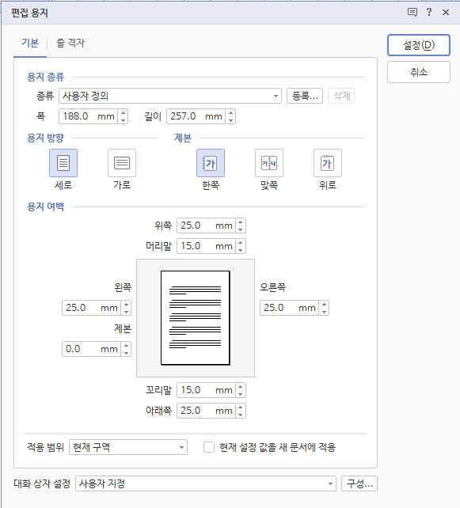 | Paper margins  (4*6 size)  Top 25.0mm  Bottom 25.0mm  Header 15.0mm  Footer 15.0mm  Left 25.0mm  Right 25.0mm  Binding 0.0mm

3. Cover: Hard cover or semi-hard cover
- Hard cover (Hardcover, final thesis/dissertation): gold-foil printing on a black background
- Perfect-bound cover (Softcover, examination copy): white 220 g woodfree paper, black-and-white printing

4. Inner pages: 80 g light-colored woodfree paper, single-sided or double-sided printing (printed so that the reverse side does not show through)

5. Printing: Except for the cover spine, landscape printing shall be the standard, and double-sided printing shall be used.

6. Fonts (Typeface): Shinmyeongjo, Humanmyeongjo

◎ Paragraph format: indent "2–3 spaces"; line spacing "160–180%"; alignment "justified"
◎ Font format:
▷ Main title: 16 pt, Shinmyeongjo, bold (centered)
▷ Section title: 14 pt, Shinmyeongjo, bold
▷ Body text: 10–12 pt, Shinmyeongjo
▷ Footnotes: 9 pt, Shinmyeongjo

Font sizes for cover and contents

Font size | Outer cover | Spine  (book spine) | Inner cover | Examination Request Form | Approval Page | Body | Thesis Summary / English Abstract
21 pt | Thesis/Dissertation Title  University Name  Name |  | Thesis/Dissertation Title  University Name  Name | Thesis/Dissertation Title  University Name  Name | Thesis/Dissertation Title  University Name
16 pt | Department  Major  Graduation Year  Date |  | Academic Advisor  Department  Major | Academic Advisor  Submission of a Thesis/Dissertation for the Degree of OO  Department of OOO(name) | Examiners | Main title | "Summary"  "Abstract"  English thesis/dissertation title
14 pt | Subtitle | Thesis/Dissertation Title  Name | Subtitle  Graduation Year  Date | Subtitle  Graduation Year  Date | Graduation Year / Date | Section title
12 pt |  | Graduation Academic Year |  |  |  |  | Content
11 pt |  |  |  |  |  | Content | Content
9 pt |  |  |  |  |  | Footnotes | Footnotes

7. Item Numbering: Prepare using a consistent sequence (see the example box below)

Category | Example A | Example B | Size and alignment
Example structure  (mid-level items may be omitted; spacing may be adjusted) | Chapter 1  Section 1  1.  a.  1)  (a) | Ⅰ.  1.  A.  1)  a.  (1) | 16 pt, bold, centered  14 pt, bold  11 pt (bold)  11 pt  11 pt  11 pt

8. Order of Thesis/Dissertation Components

① Outer cover ② Inner cover ③ Approval Page ④ Thesis Summary ⑤ Table of Contents ⑥ Body ⑦ References ⑧ Appendix ⑨ Abstract (English abstract)

□ Thesis/Dissertation Typesetting Guide

1. Outer cover
- In principle, the thesis/dissertation title shall be in Korean (Korean-only or mixed Korean/Hanja (Chinese characters) permitted). However, where it cannot be expressed in Korean, it may be stated in English.
- Where the title exceeds one line, the second line shall be centered and balanced.
- Where there is a subtitle, it shall be positioned centered below the main title.
- The university name, department, major, etc. shall be written in Hanja (Chinese characters).

2. Spine (book spine)
- The spine is for binding only and shall not be included in body printing.
- Only the thesis/dissertation title shall be shown (no subtitle).
- The year refers to the graduation year, shall be written in Arabic numerals, and shall be printed vertically.
(Example: February 2025 (Winter 2025) or August 2025 (Summer 2025))

3. Inner cover: Same as the outer cover; the thesis/dissertation title must also be shown in English.

4. Examination Request Form
- Same as the inner cover; however, below the English title, state: "This thesis/dissertation is submitted as a thesis/dissertation for the degree of OO in OO."
(Example: For a doctoral student in the general graduate school, Department of History, Major in Mechanical Engineering, the statement is written as "This thesis is submitted as a doctoral dissertation in engineering.")

- The date on the Examination Request Form shall be written as "June 2025" or "December 2025" (Review Month).

5. Approval Page
- Signatures of the chair of the examination committee and all examiners (including the Academic Advisor) are required.
- The date on the Approval Page shall be written as "August 2025" or "February 2026" (month may not be changed).

6. Thesis Abstract
- Must be within two (2) pages, and keywords for thesis/dissertation searching shall be provided in no more than six (6) words.

7. Body
- The body shall be prepared at approximately 38 characters ￗ 25 lines per page.
- Page numbers shall be placed at the bottom center of each page.

8. English Abstract
- The abstract shall be written in English and, like the Korean summary, shall focus on research objectives, methods, and results.
- Where the body is written in a foreign language, the abstract must be written in Korean.

9. Submission of Thesis/Dissertation
- Number of final theses/dissertations (hardcover) to submit: Master’s 4 copies; Doctoral 4 copies
- Submission destinations (printed copies): Graduate School 2 copies; Central Library 2 copies
※ Final copies must include examiner seals/signatures (submitted in color).
- The original Approval Page (with examiner signatures/seals) shall be brought when submitting the printed copies; after final pass confirmation, the student shall keep it.
- Online submission of thesis/dissertation
· Access the online thesis/dissertation submission site dCollection(http://chains.dcollection.net), enter thesis/dissertation information, and upload the electronic file.
※ Be sure to refer to the separately announced "Thesis/Dissertation Registration Guide."
· After online submission, print and seal the "Submission Confirmation" and "Copyright Consent Form," and submit them to the Graduate School together with the final thesis/dissertation.
- Examination copies: Master’s 4 copies; Doctoral 6 copies (submit to the relevant department; subject to change depending on department circumstances).

※ After preparing the thesis/dissertation using the form distributed by the Graduate School and undergoing examination (A4 printouts), bind and submit the final thesis/dissertation in 4ￗ6 size.
※ The online electronic file and the printed copies must match exactly.
※ Order of forms: Outer cover, spine (spine cover), inner cover, Examination Request Form, Approval Page, thesis summary, table of contents, body, Abstract (English abstract).

